# ANSIBLE

Rajesh Pattapu

## Method-1

### Creating the AWS resources by using the playbook script.

1. We have to launch an instance by using amazon-linux-2.

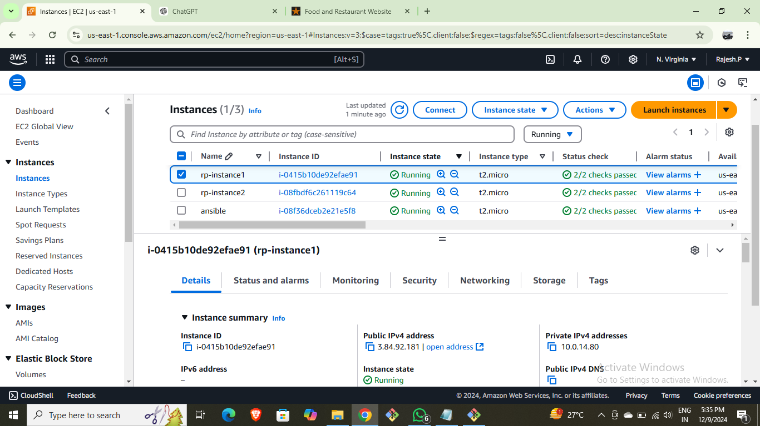

1. Connect to the terminal and update it.
2. Install the ansible “sudo amazon-linux-extras install ansible2”.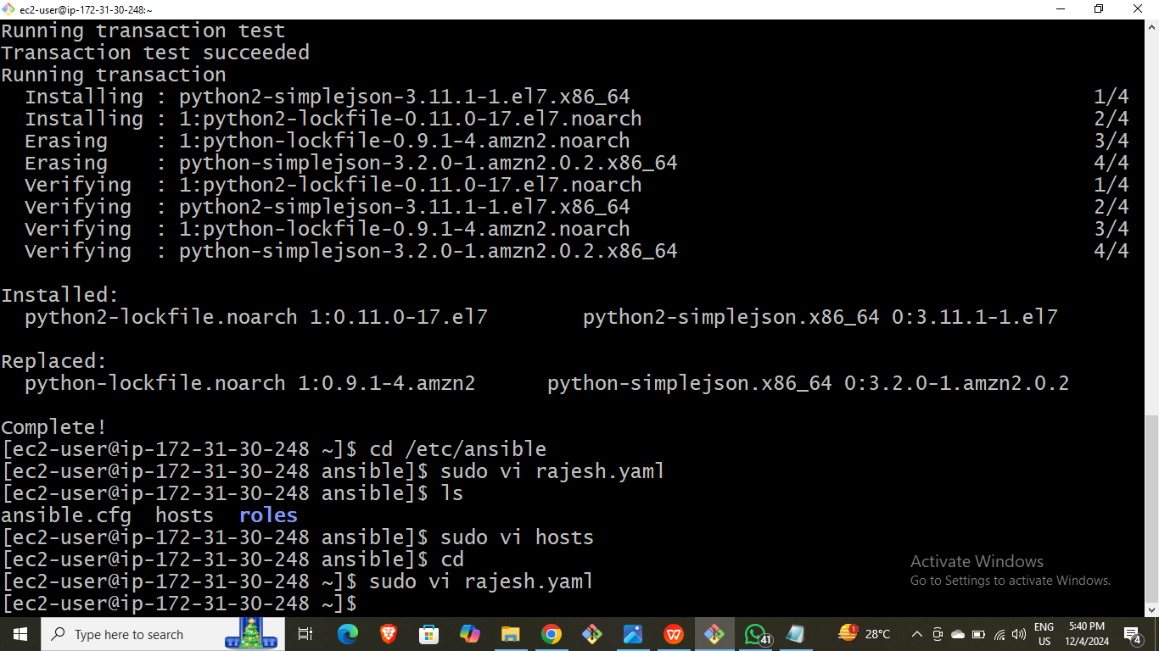
3. Copy the pem file from the device to the local server “scp –i pem pem ec2-user@pub_ip:~”
4. Give permission for pem file.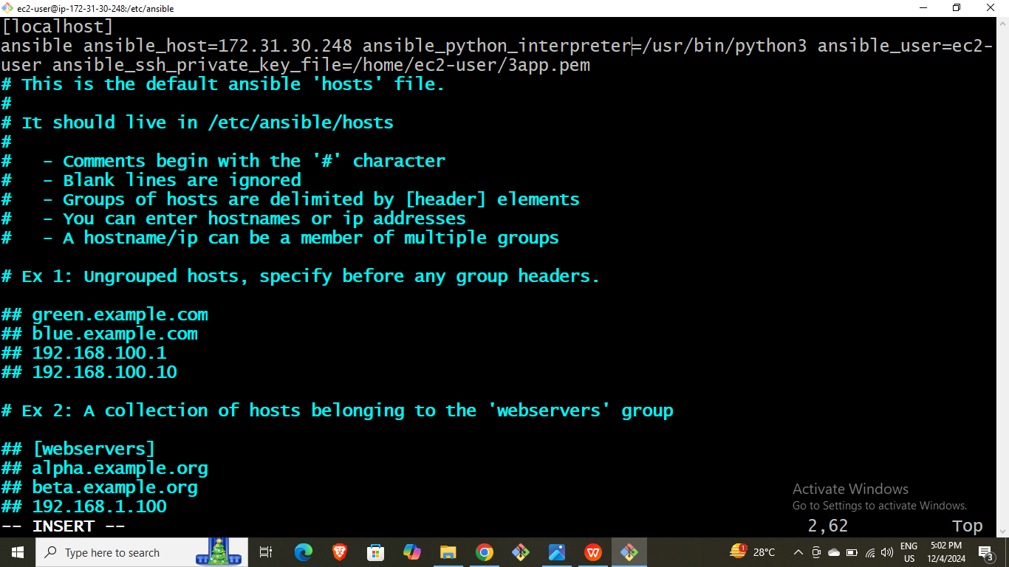
5. Edit the host file as shown in below.

cd /etc/ansible/

1. Edit the configure file as shown in below.

cd /etc/ansible/

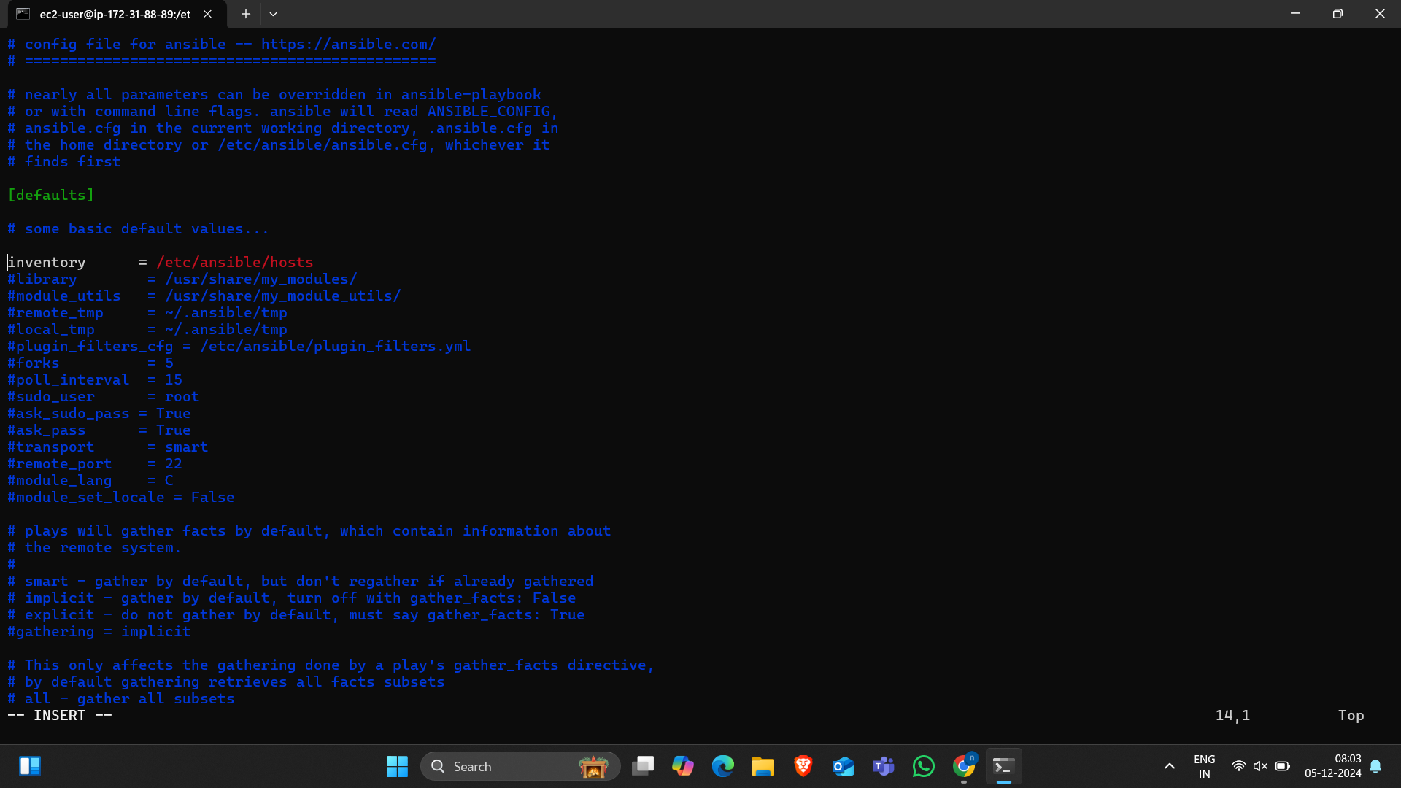

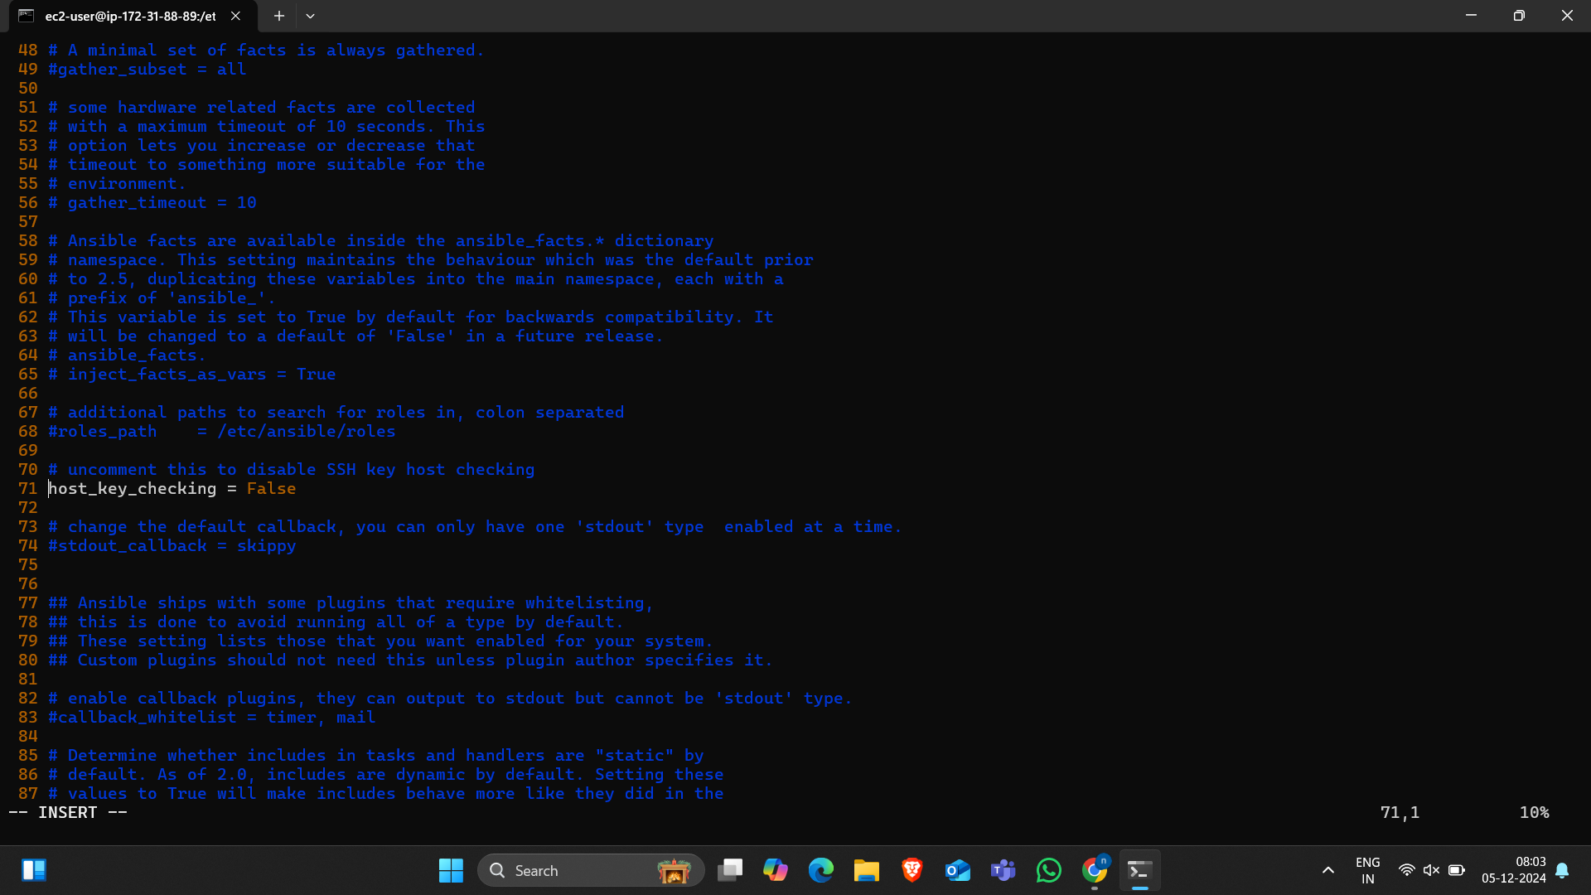

1. Go to path /usr/bin/python3 and install boto boto3 botocore.

“sudo pip3 install boto botocore boto3”

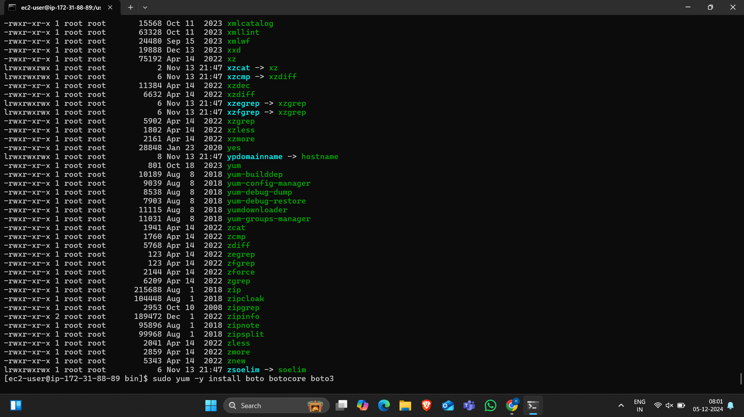

1. Create the file “name.yaml” and write the yaml script for the creating resources.

As shown in below pictures.

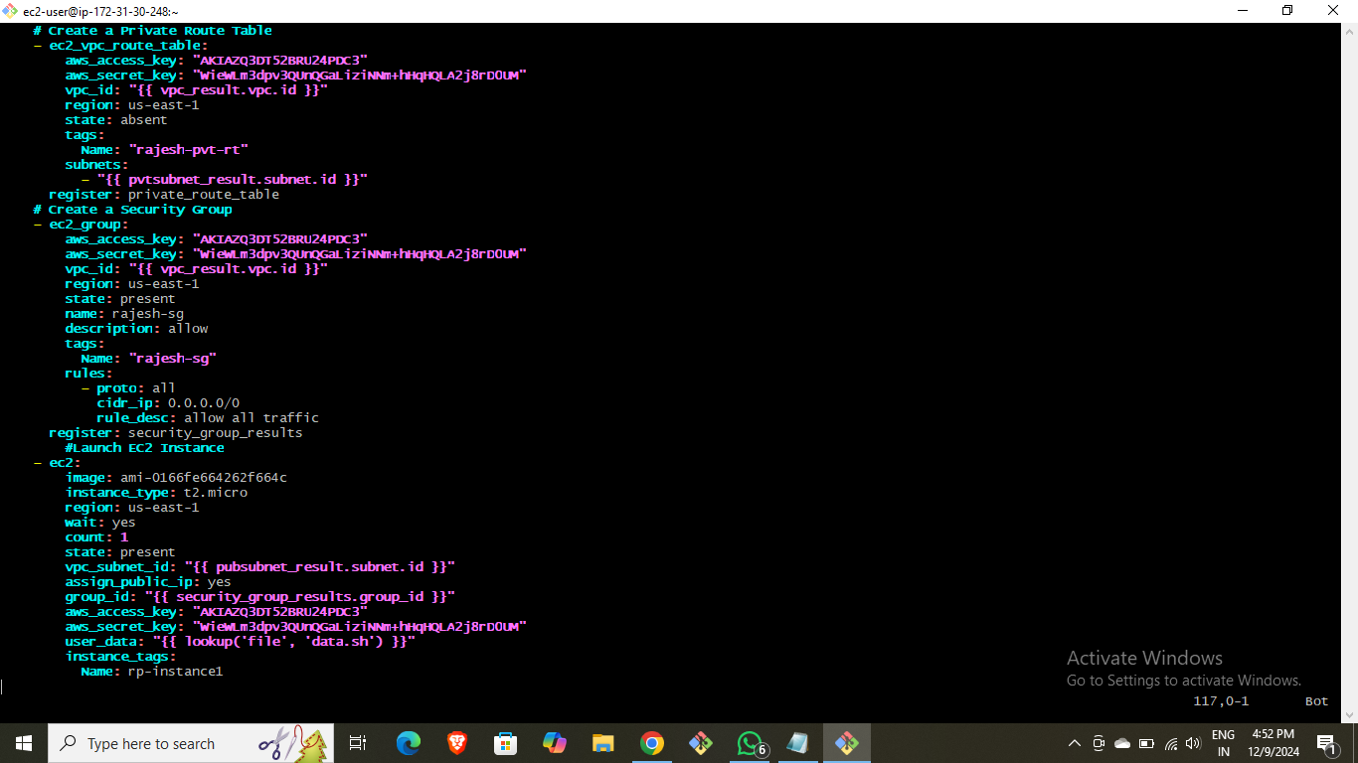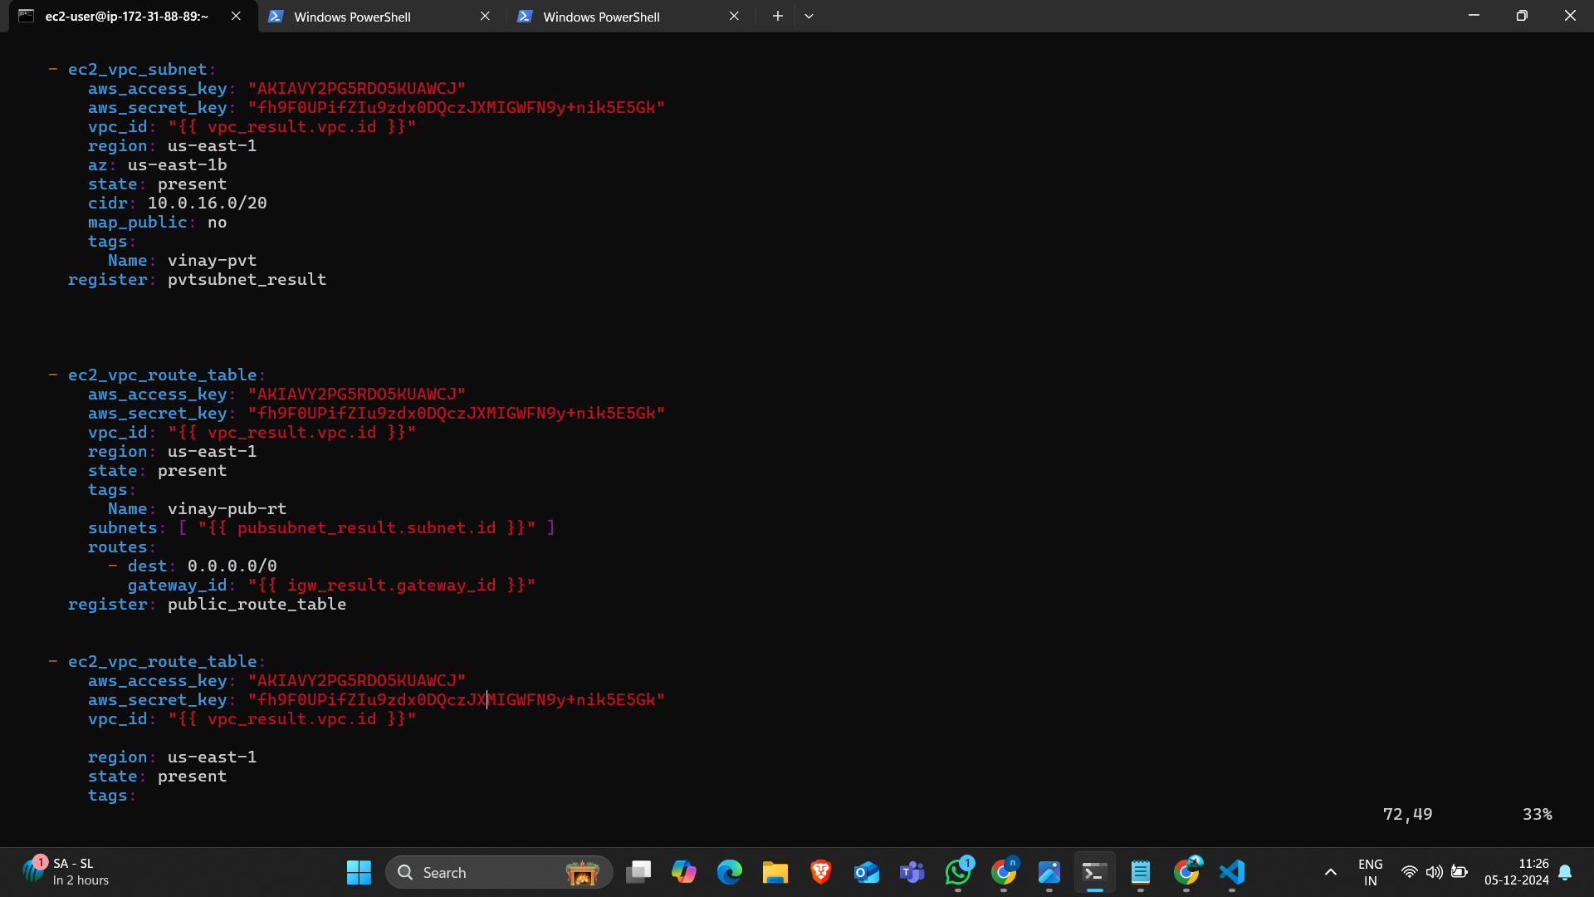

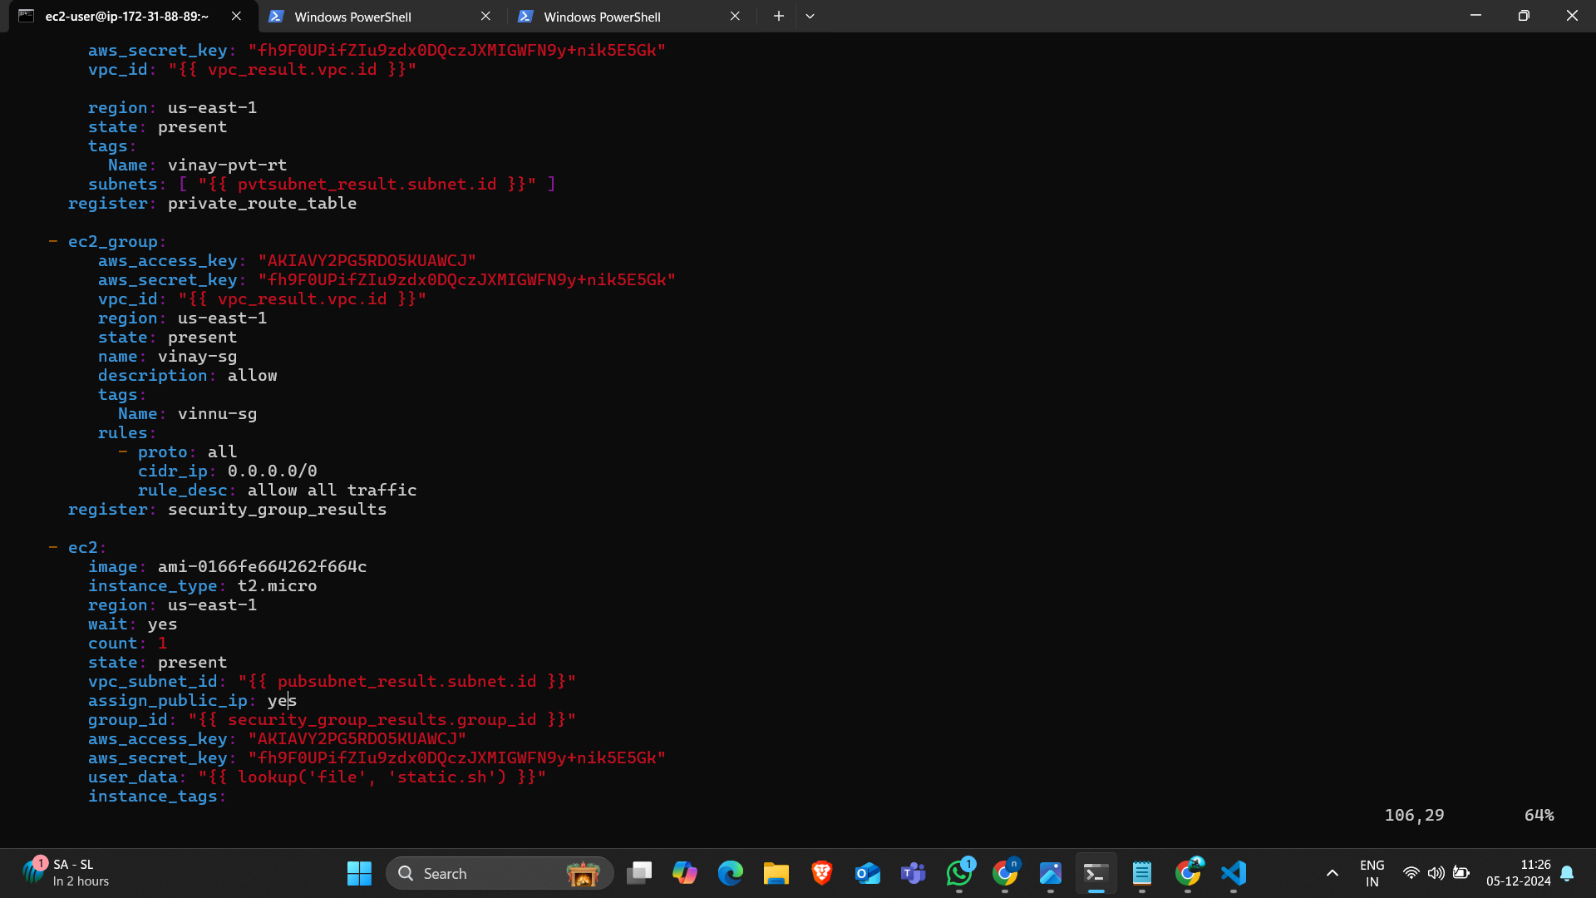

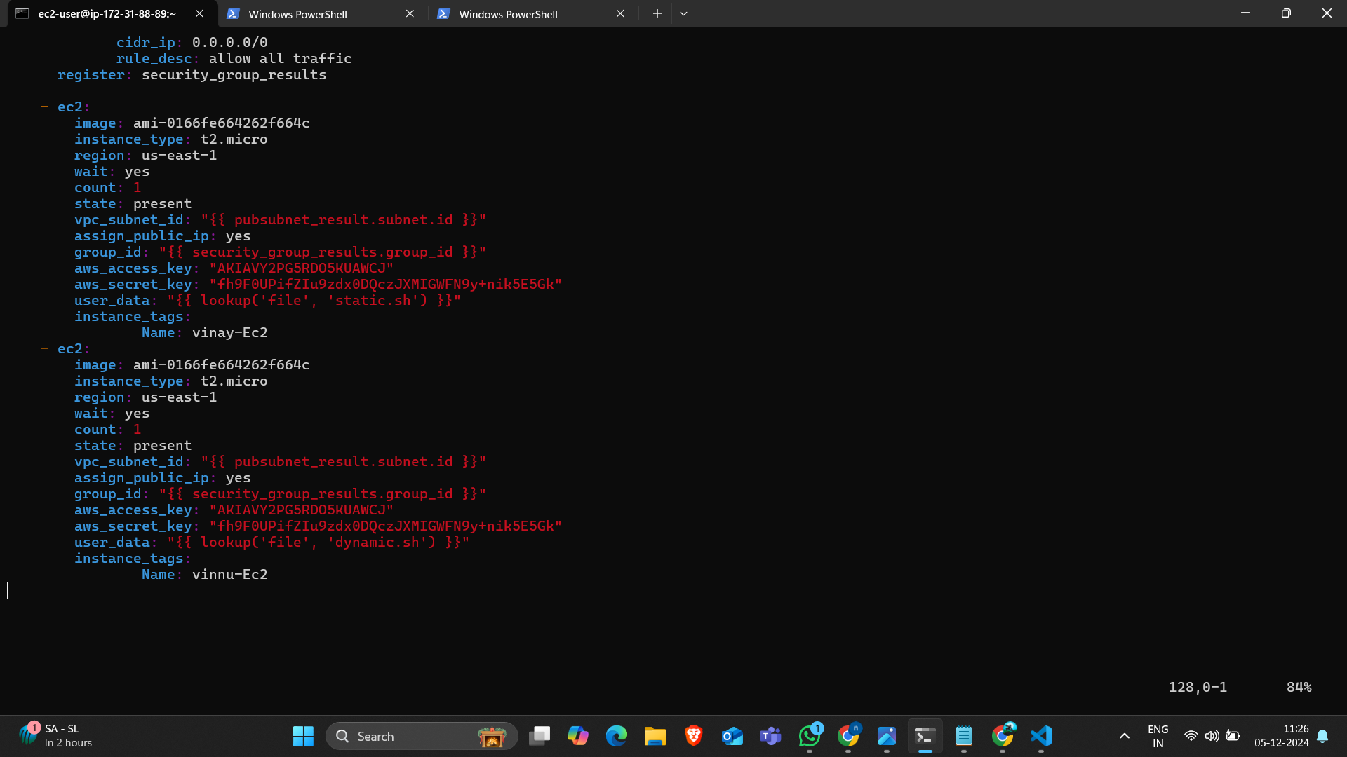

1. Create the userdata file “userdata1.sh” to host an application.Here this is a static webapplication script.

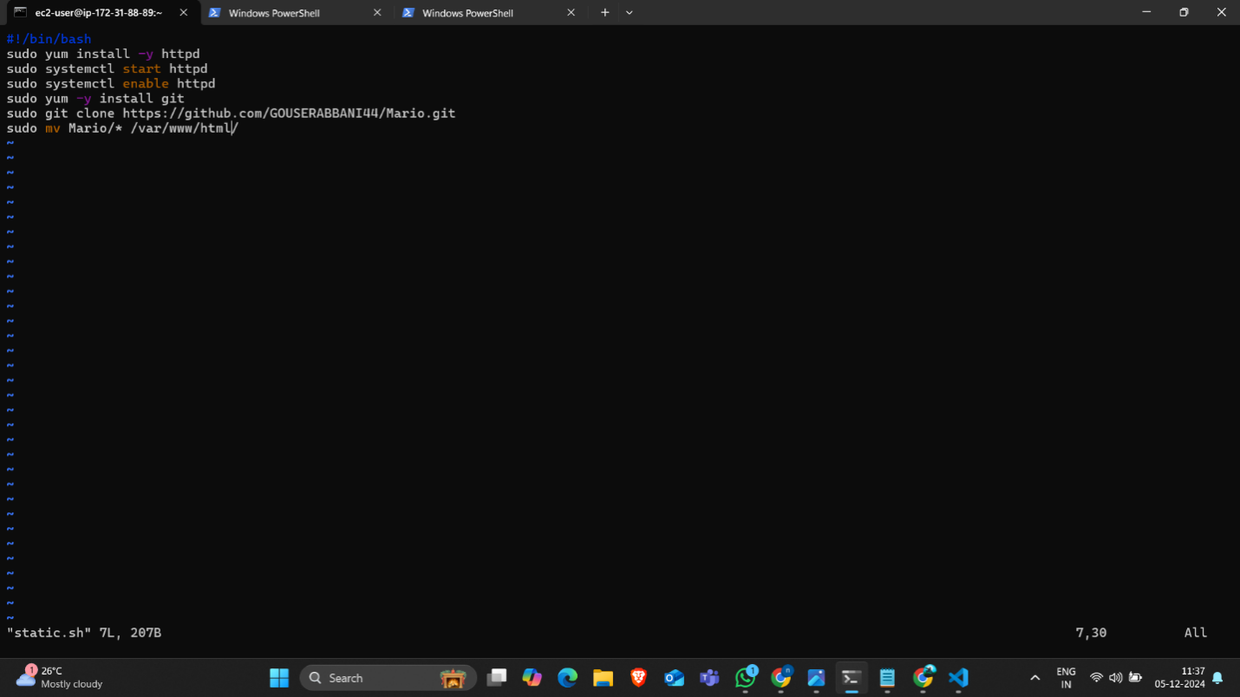

1. This the user data to host dynamic application.

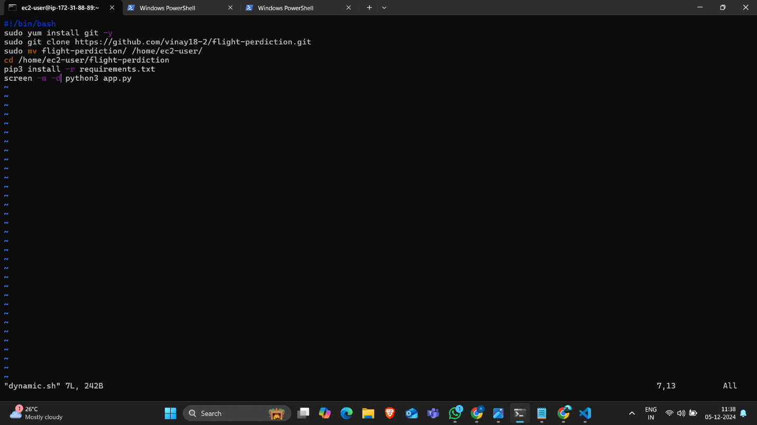

1. After writing the script than save it and execute that playbook by using the command

“ansible-playbook task.yaml”

1. We can observe that the playbook has been created successfully.

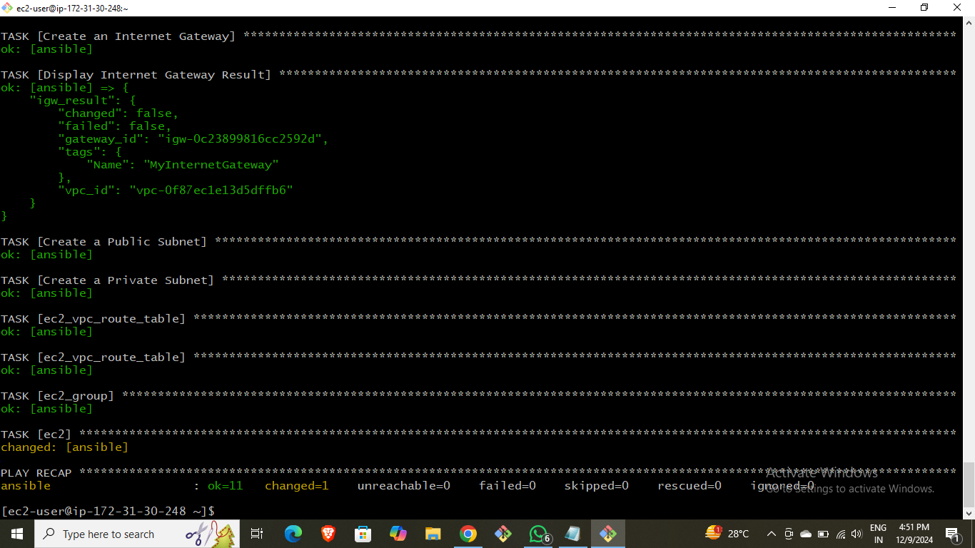

1. Here the result of created instances by using playbook script.



1. Here one instance I have hosted the static application. Copy the public ip of created ec2 instance and search in the google with port number 80.



1. Here the result of hosted static application

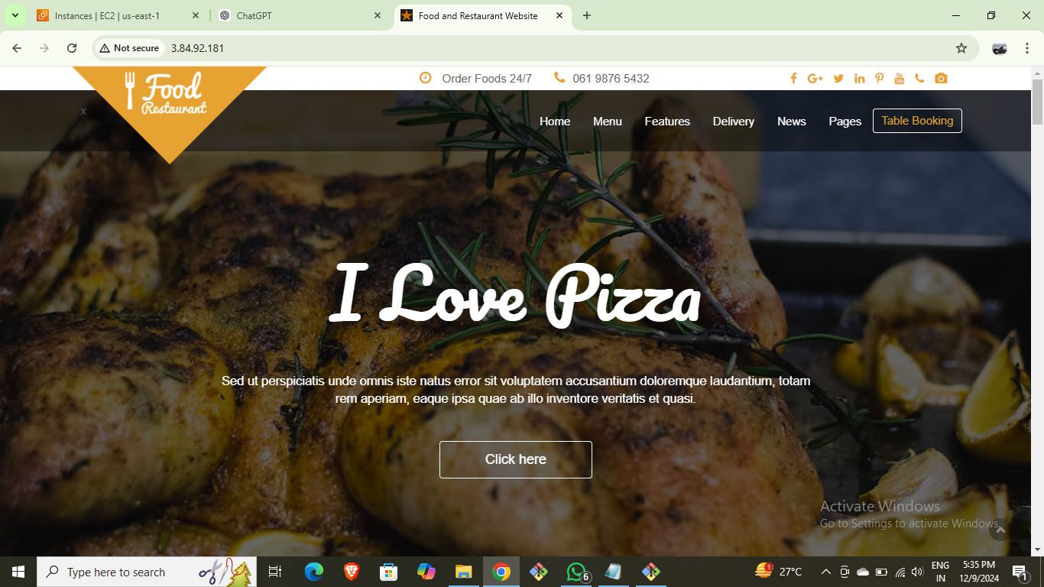

1. In the another instance I have hosted the dynamic application.
2. The result of dynamic application.

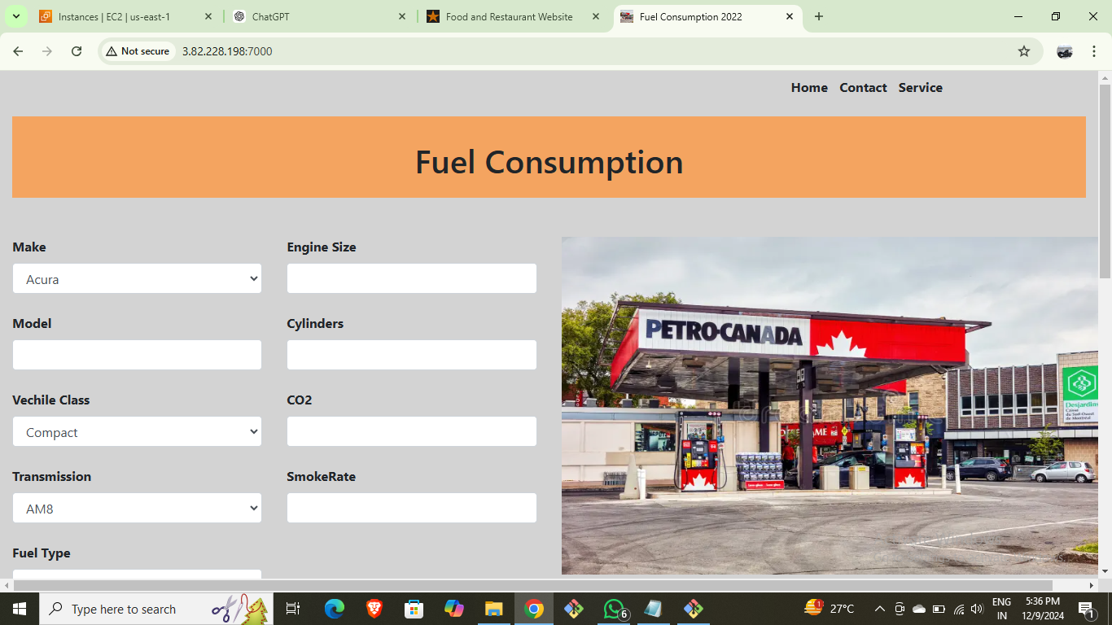

1. Here we can observe that the resources like VPC,Subnets,Route tables,Internet Gateway and created by using the playbook script.

* VPC.
* Subnets.
* Route tables.
* Internet Gateway.
* Security group.

1. And again write the playbook script for the deleting of the created resources by using playbook.
2. Create a file “delete.yaml”
3. And execute the command “ansible-playbook delete.yaml”

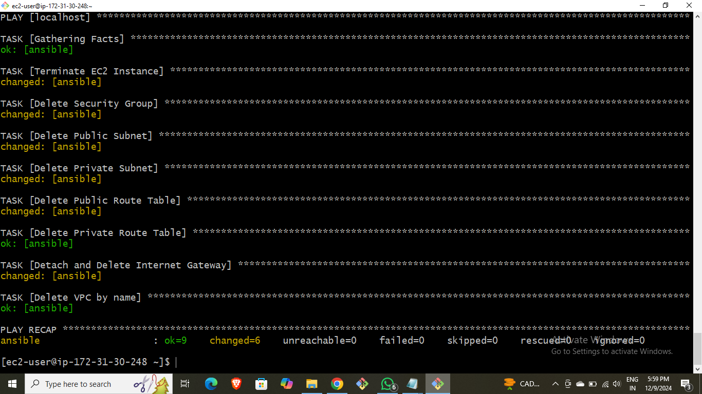

22.we can observe that the resouces are deleted.

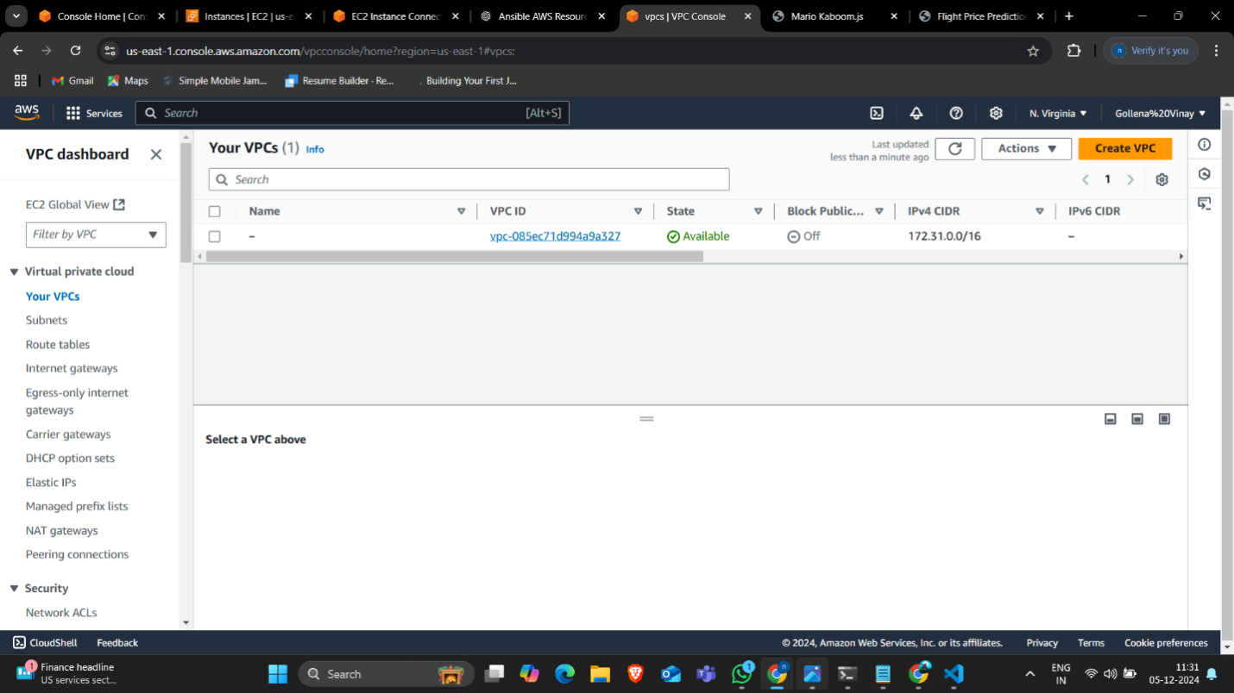

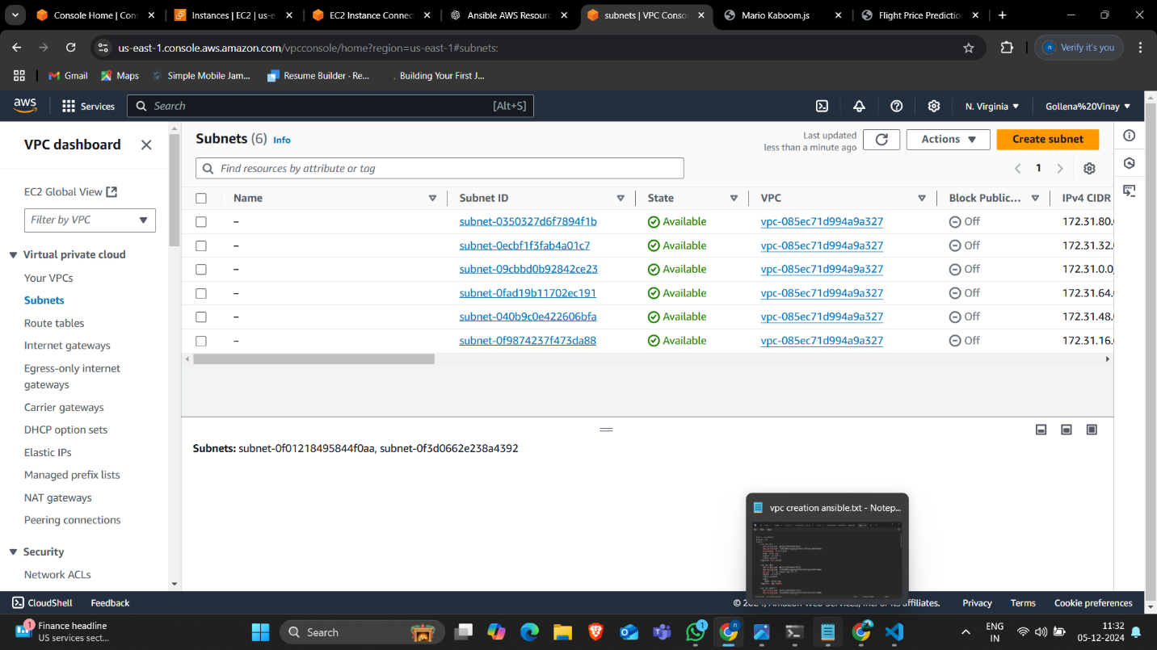

23.this the playbook script for the deletion.

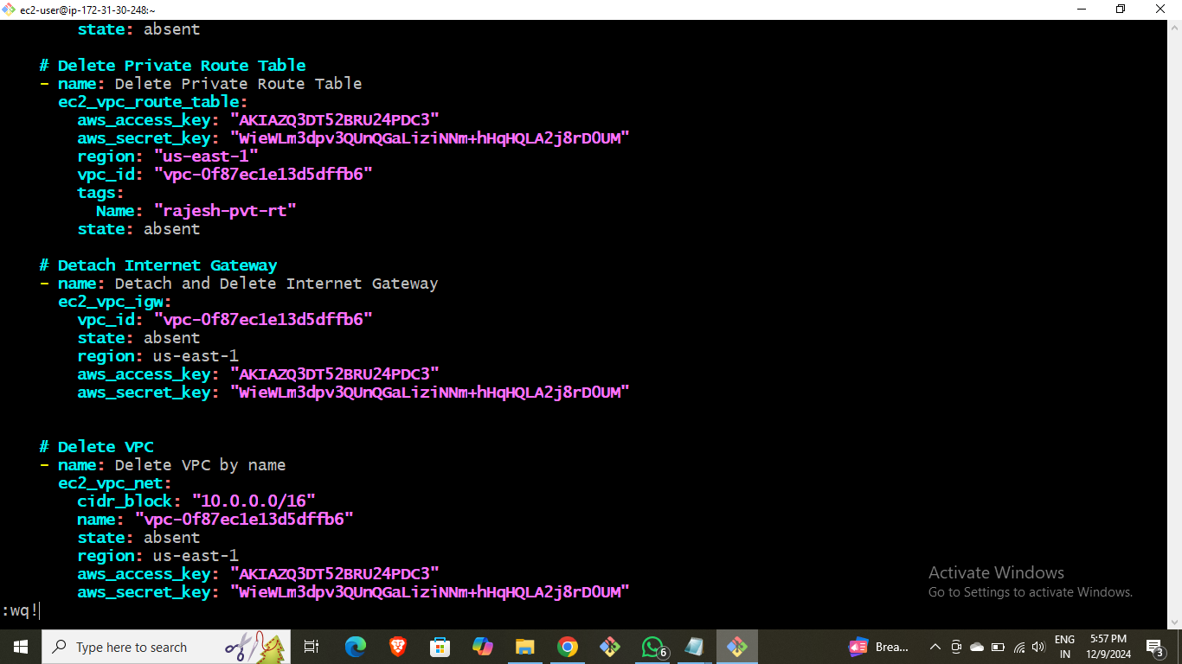

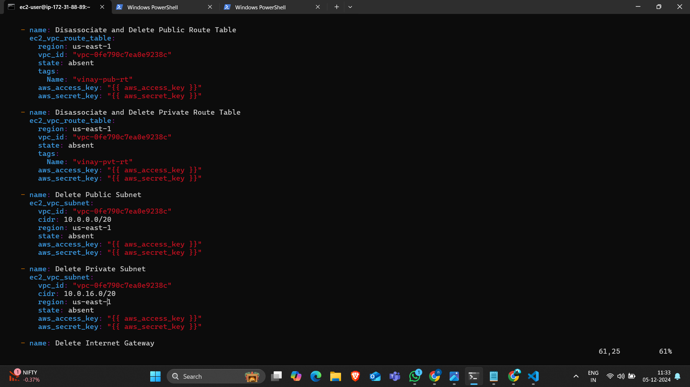

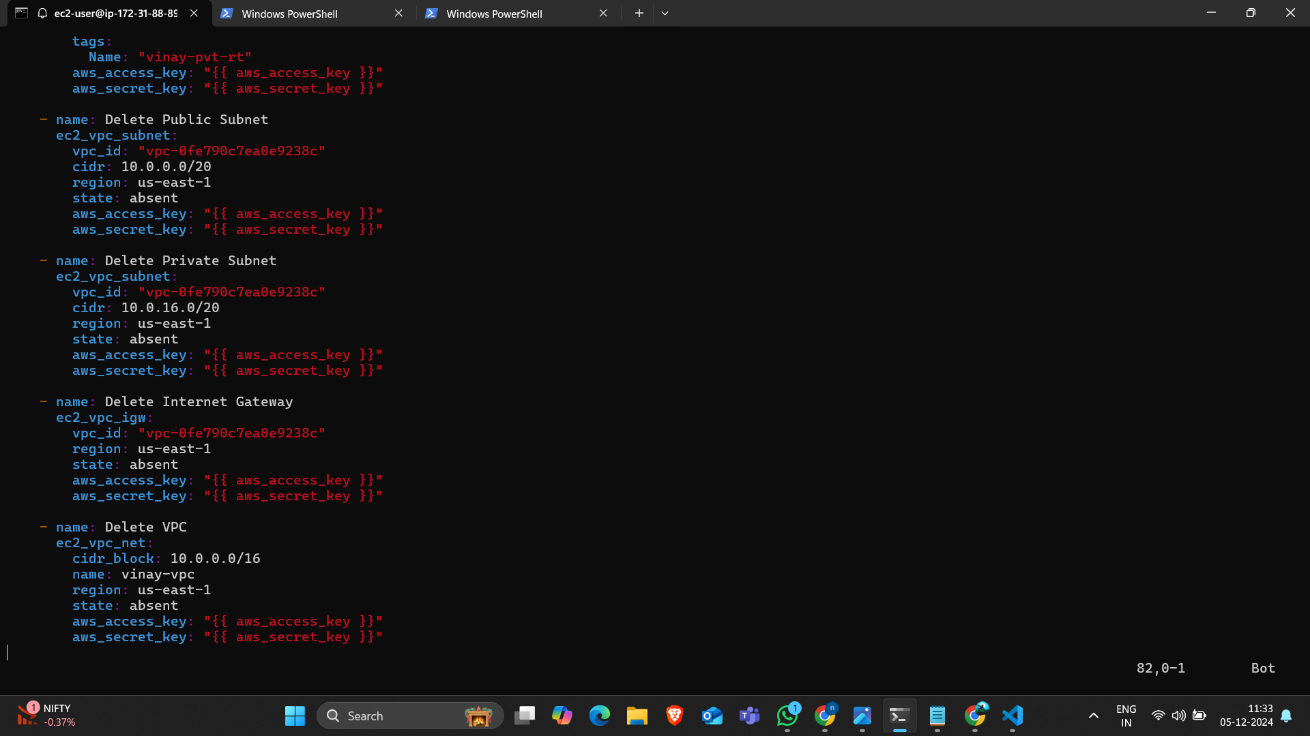

## Method-2 (Inline Variables)

### Creating the aws resources and hosting the static and dynamic application by using the Inline variable for playbook script.

* Launch an instance using amazon-linux.

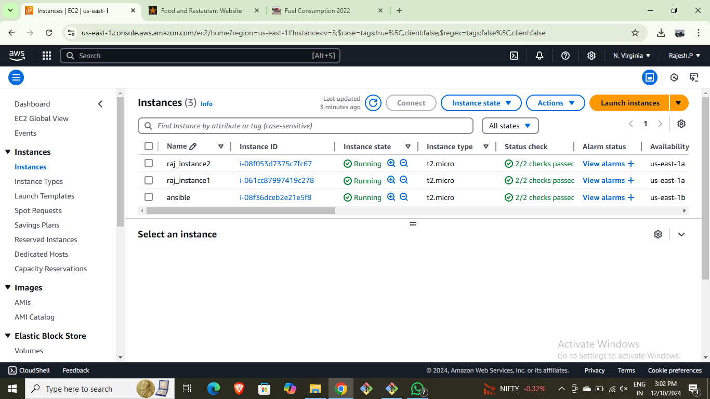

* Connect it to the terminal and update it.
* Than install ansible.

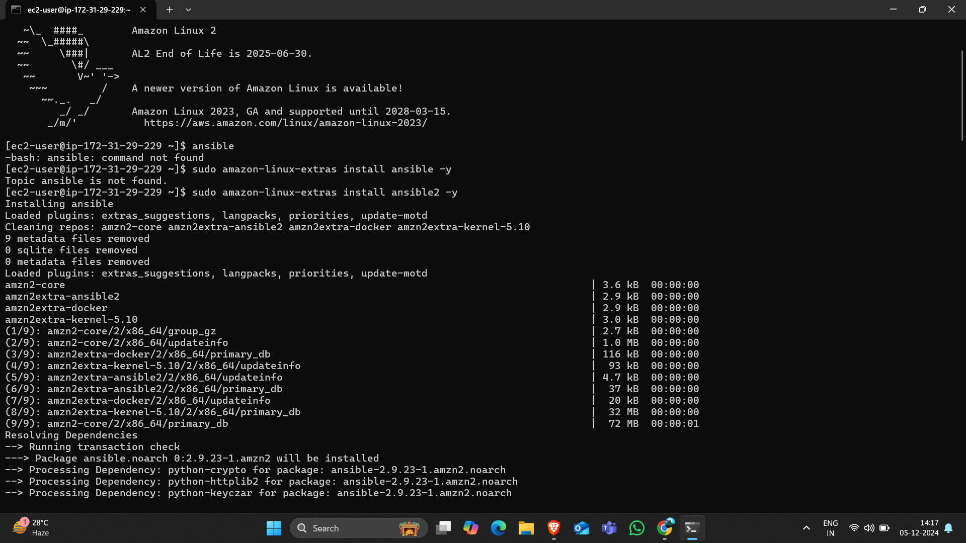

* Edit the configure file.

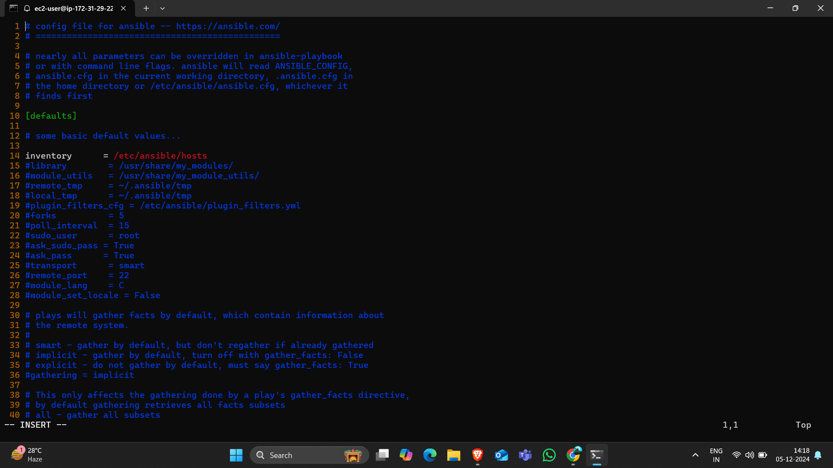

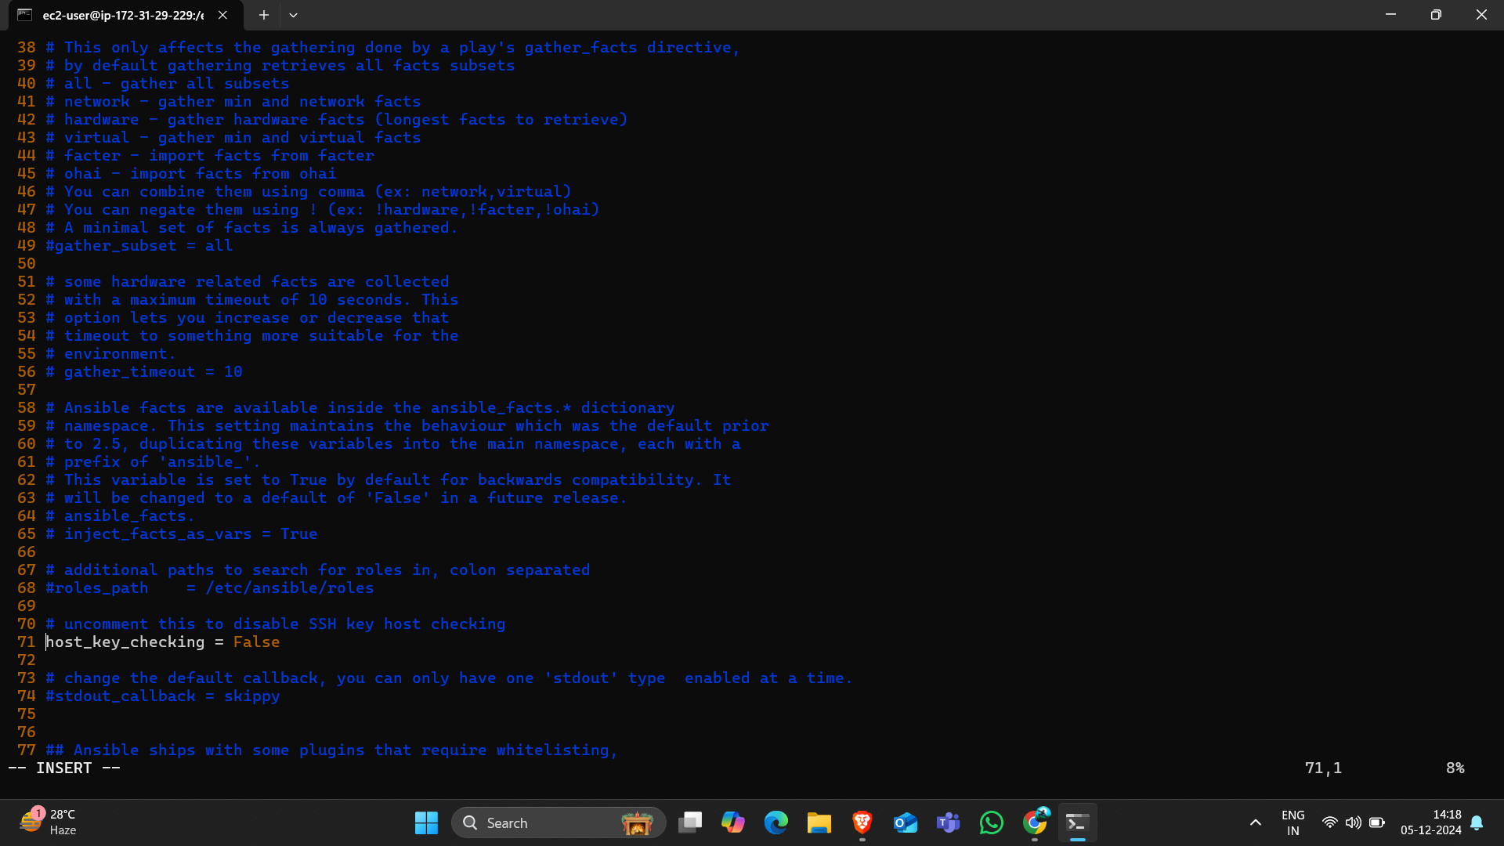

* Edit the hosts file.



* Copy the pem file and give execute permissions to the pem file.

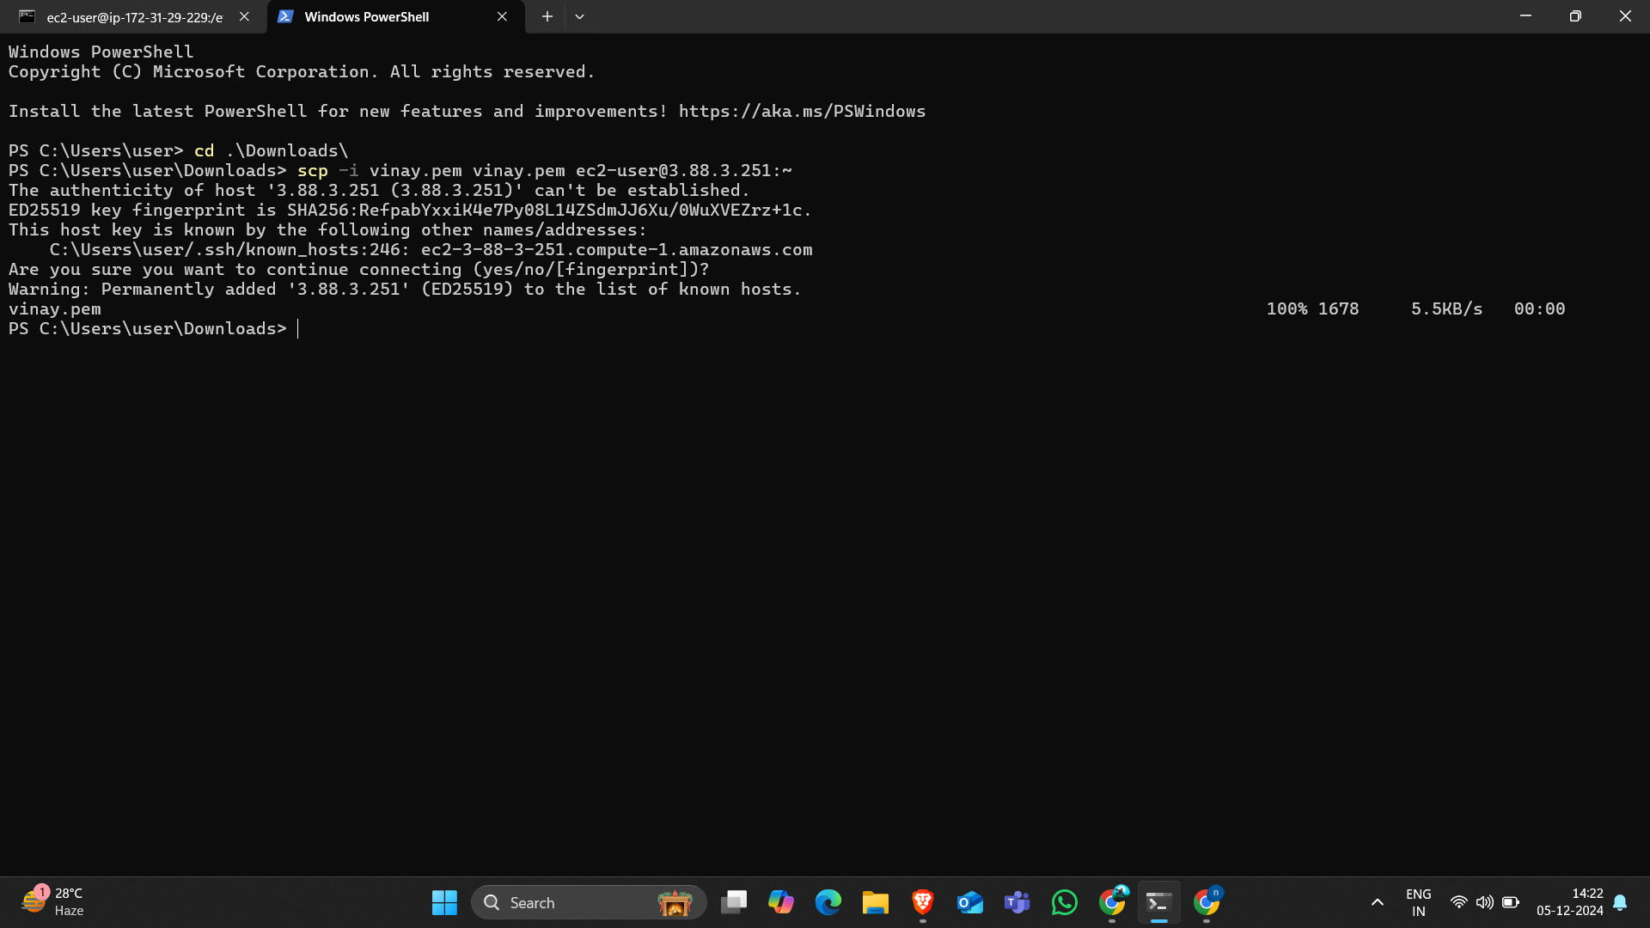

* Give the permission to the pem file.

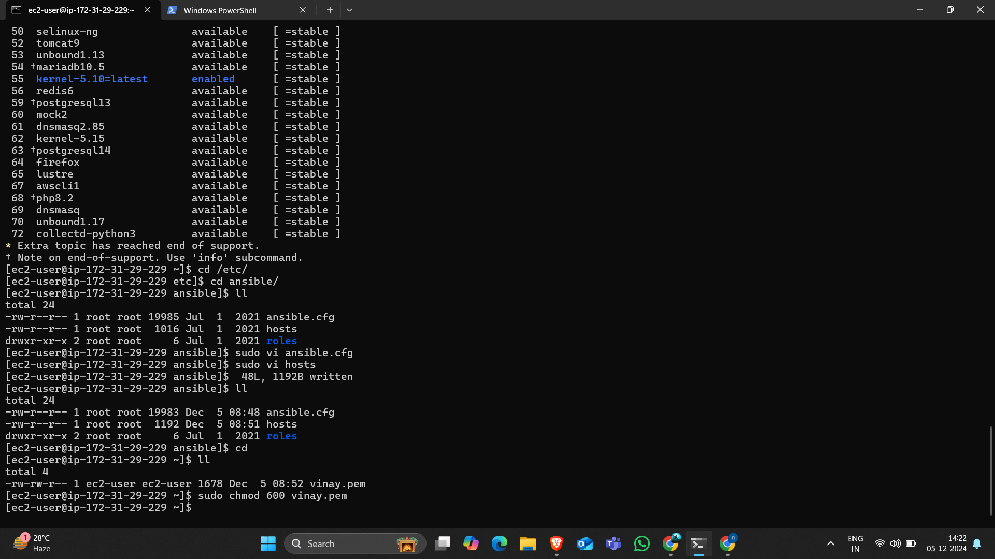

* Install the boto boto3 botocore.

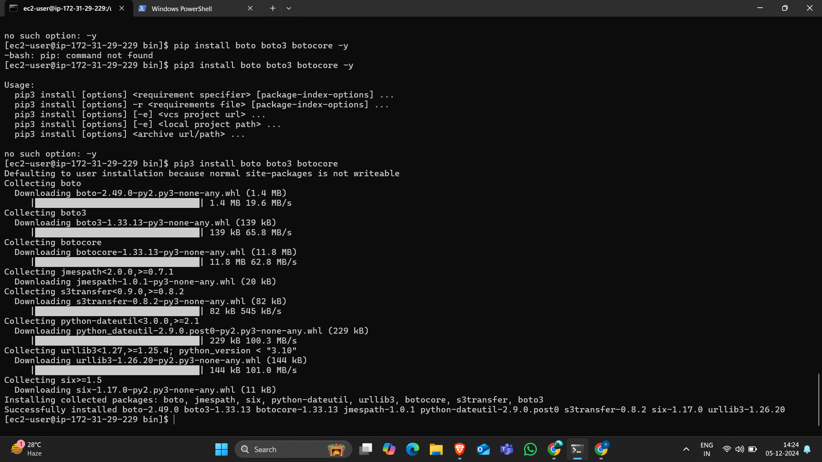

* Create the playbook file and run the the file “ansible-playbook file,yaml”

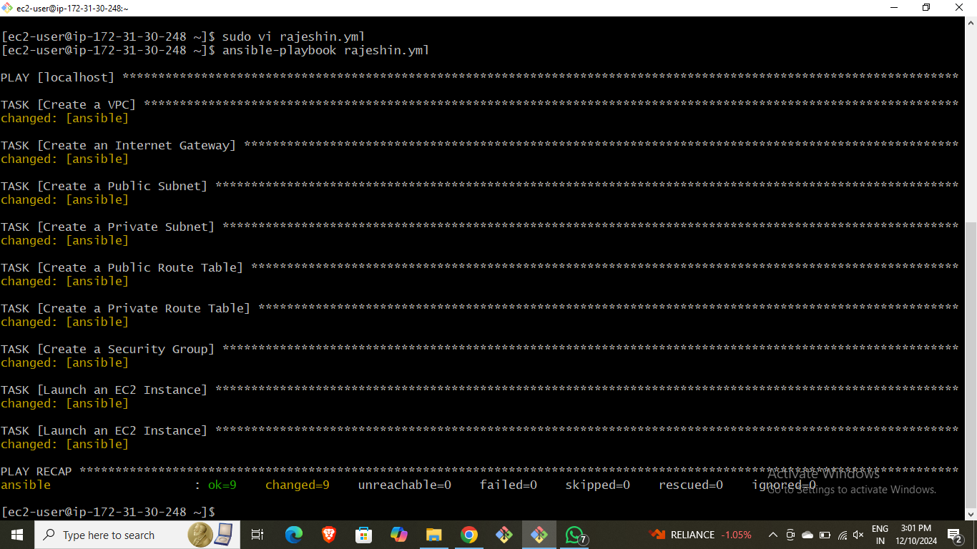

* Here is the script for the Inline variable and resources.

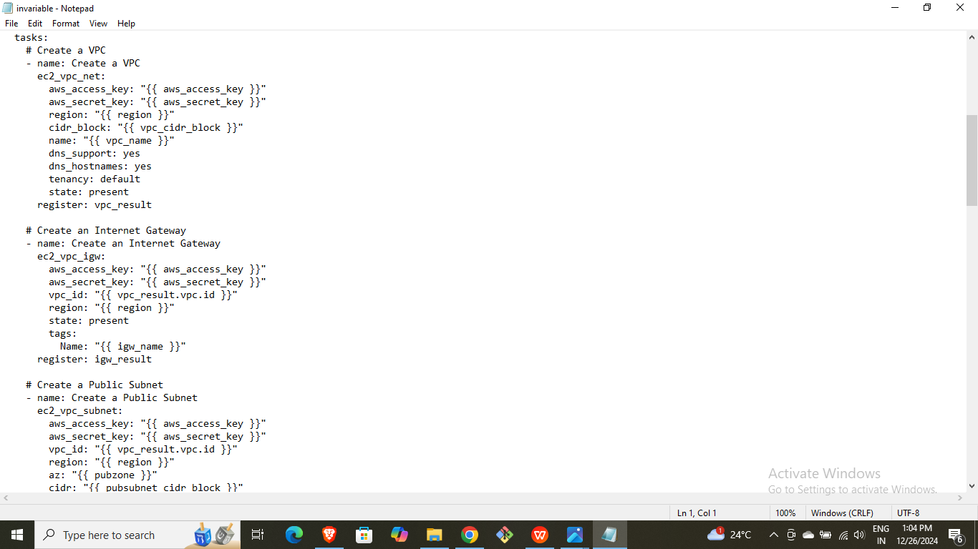

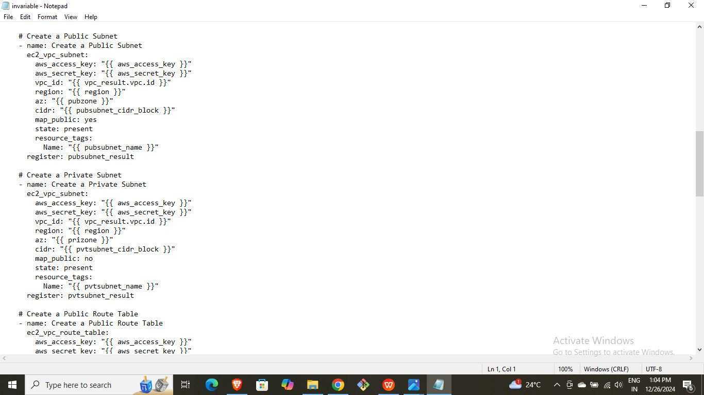

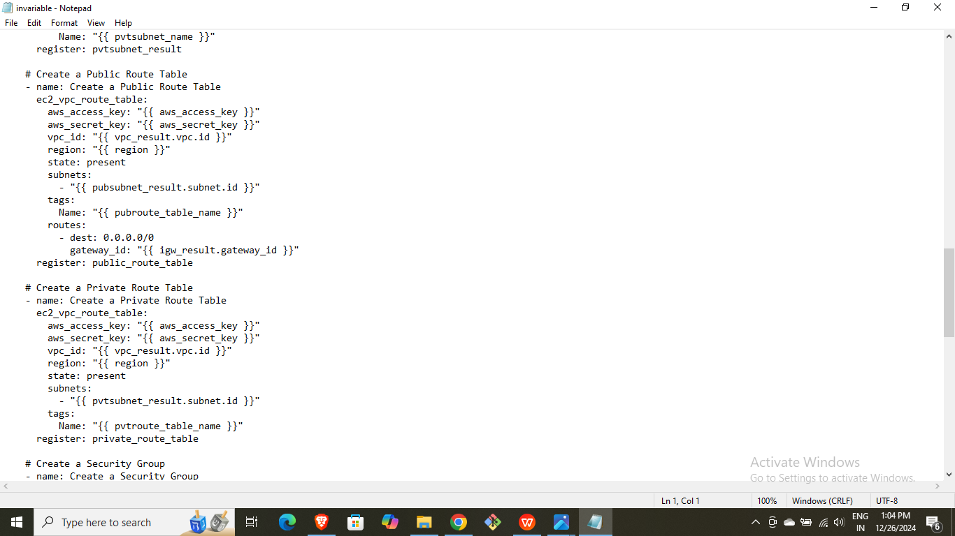

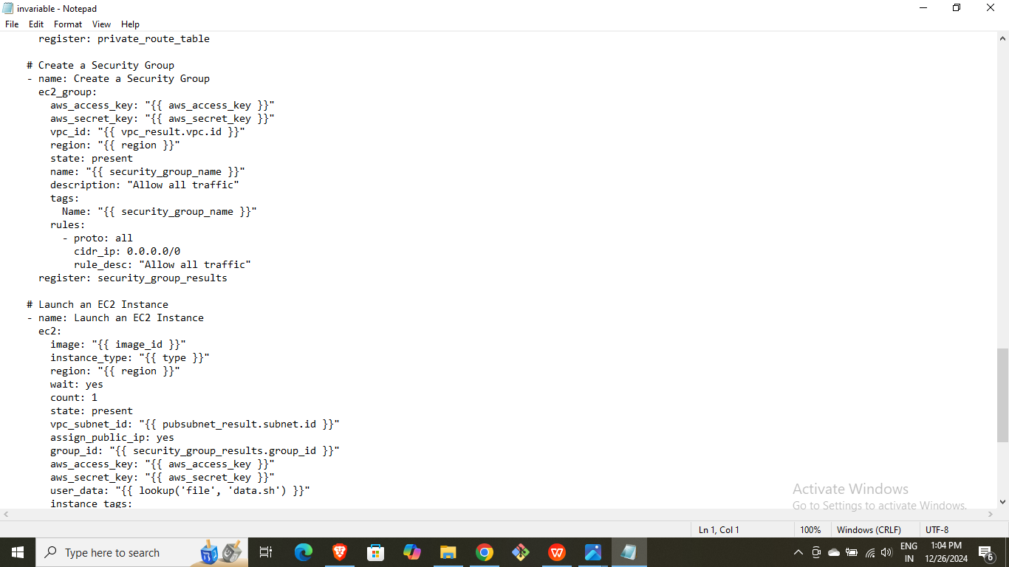

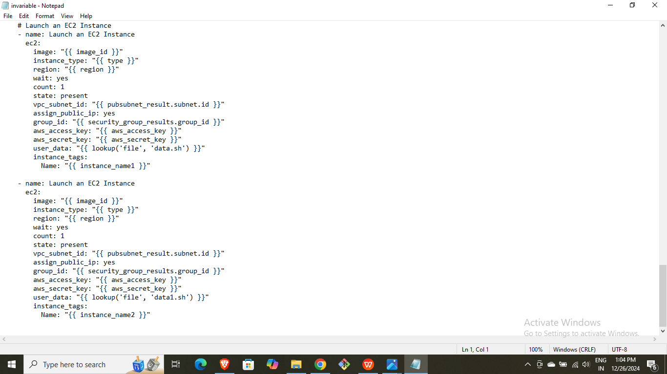

* Static.sh file.
* Dynamic.sh file.
* Here the created resources results.

1. Instance-1



1. Result os static website in instance-1.

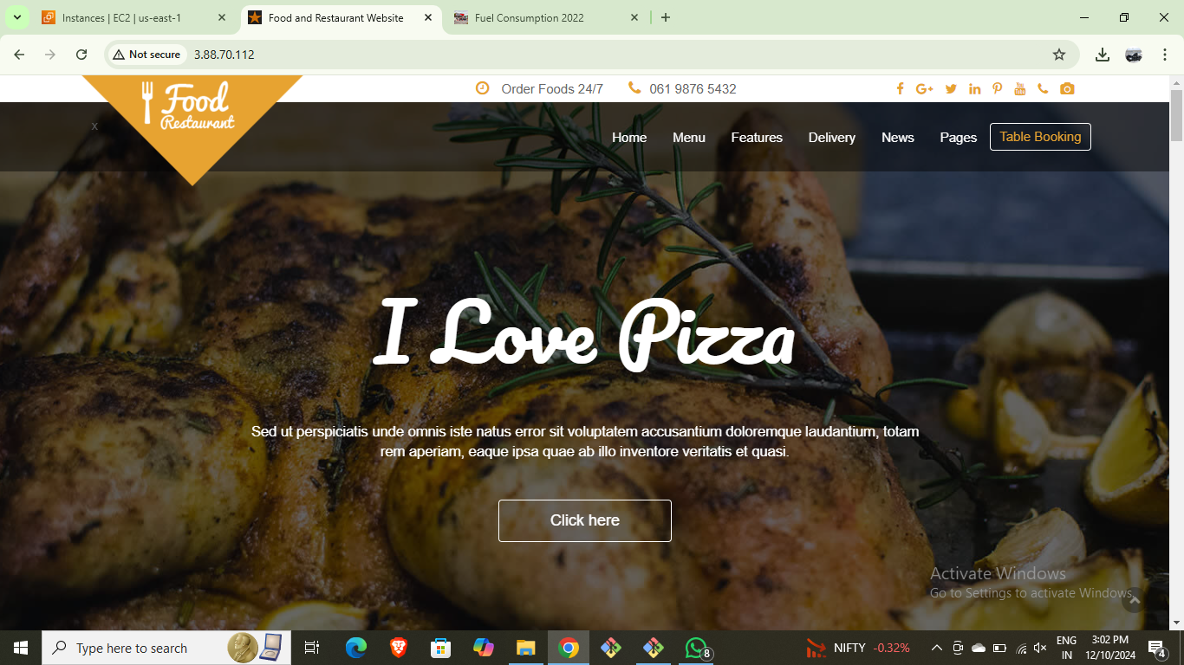

1. Result of instance-2.
2. Hosted dynamic application.

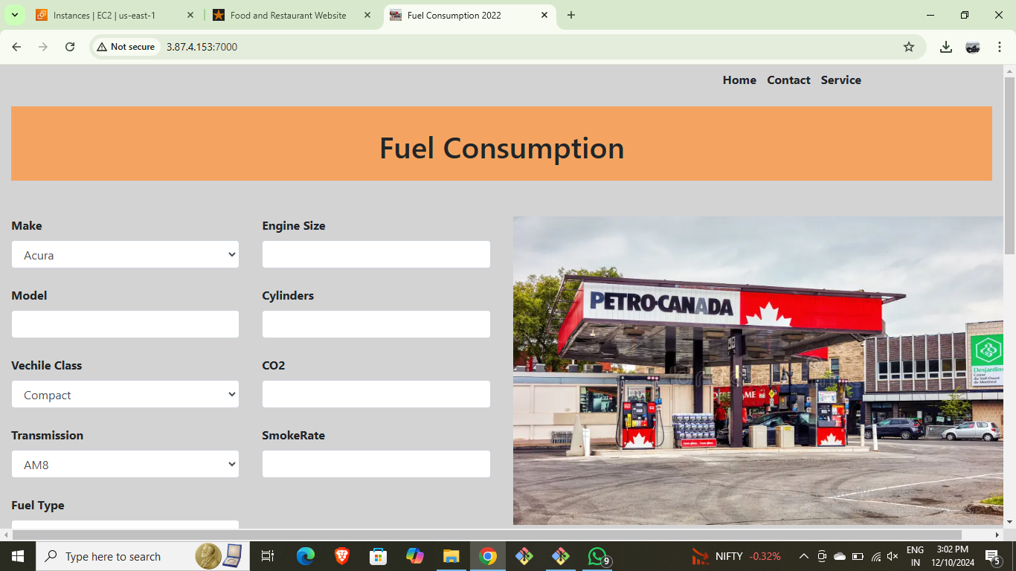

* Than write the deletion playbook file to delete the created resources.
* Execute that file.

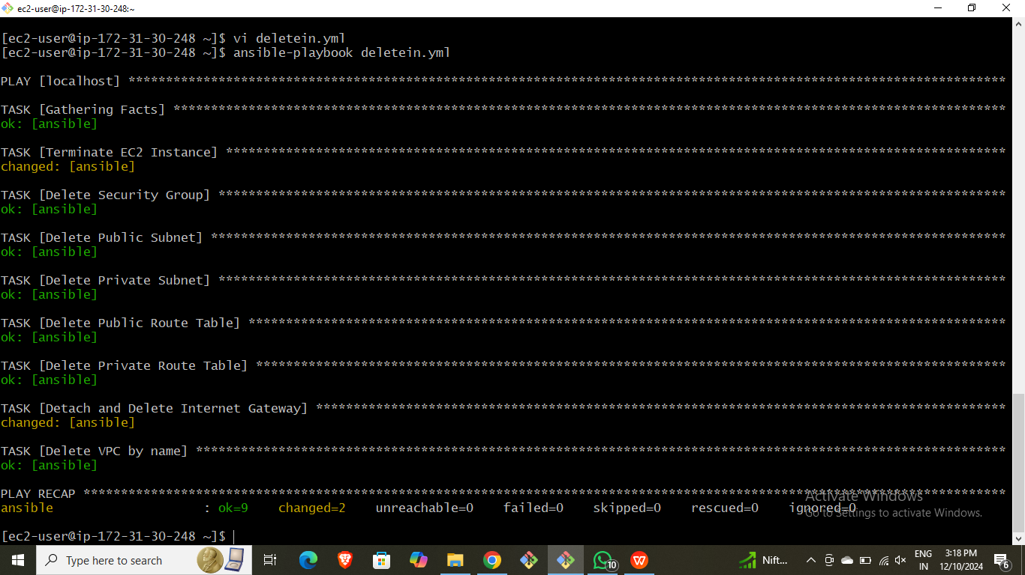

* Script for deletion.

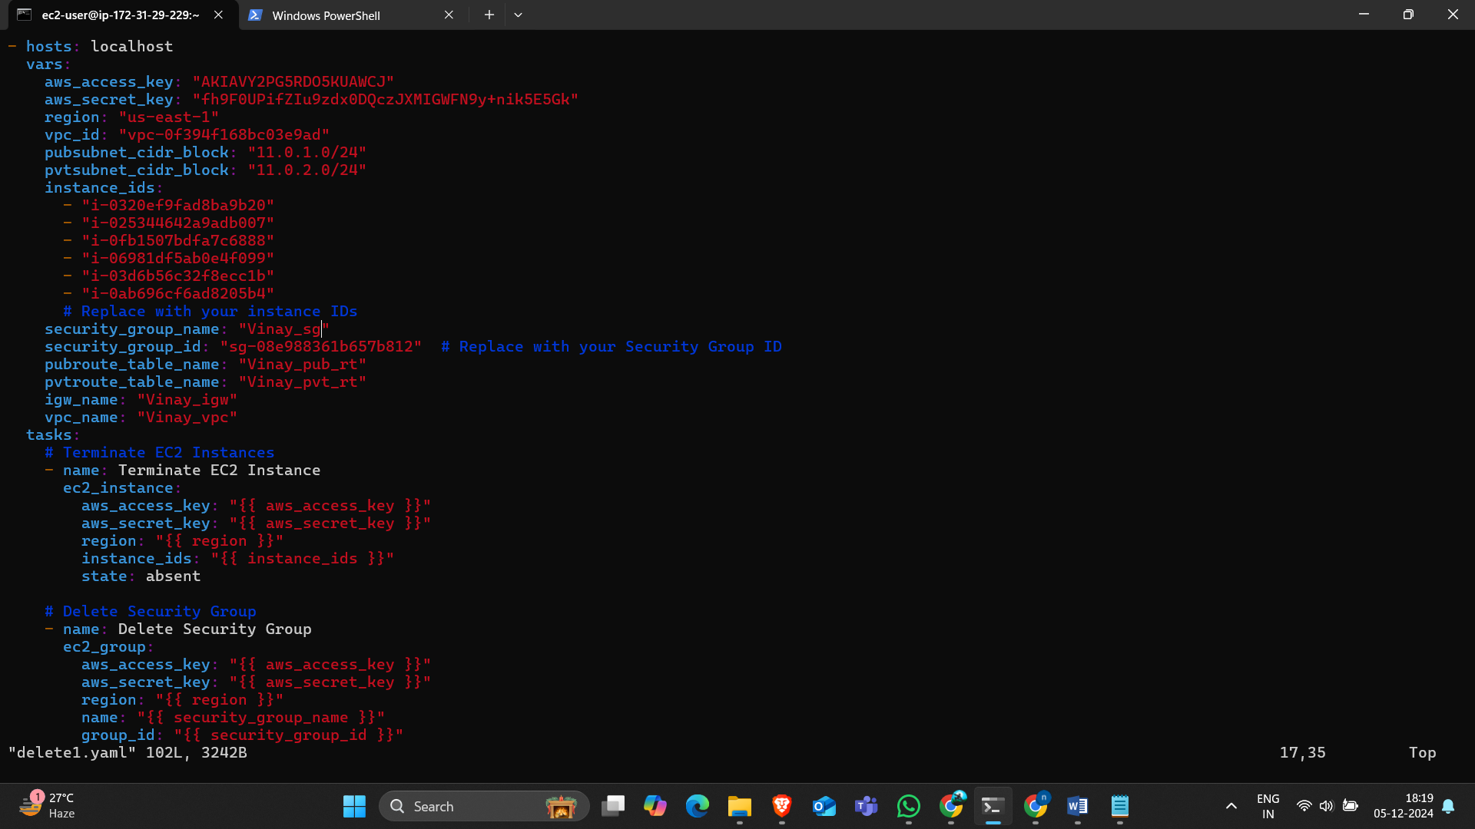

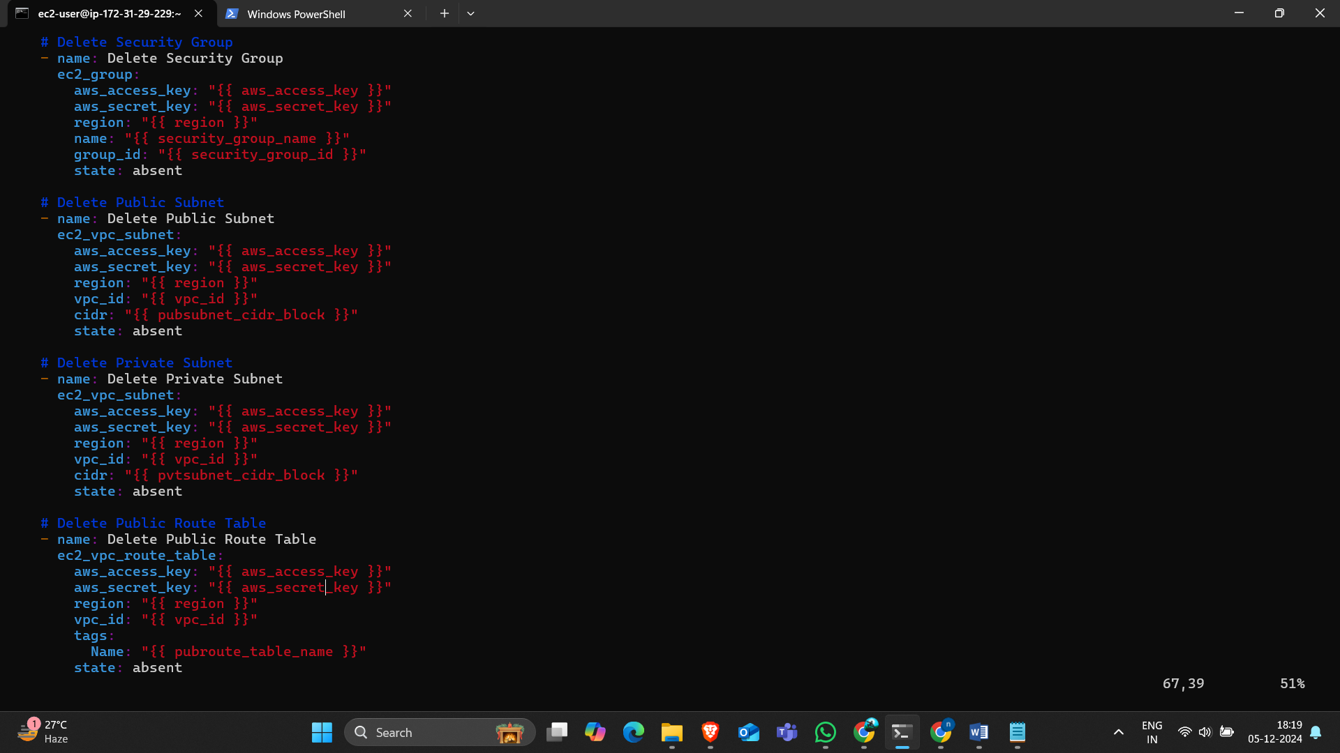

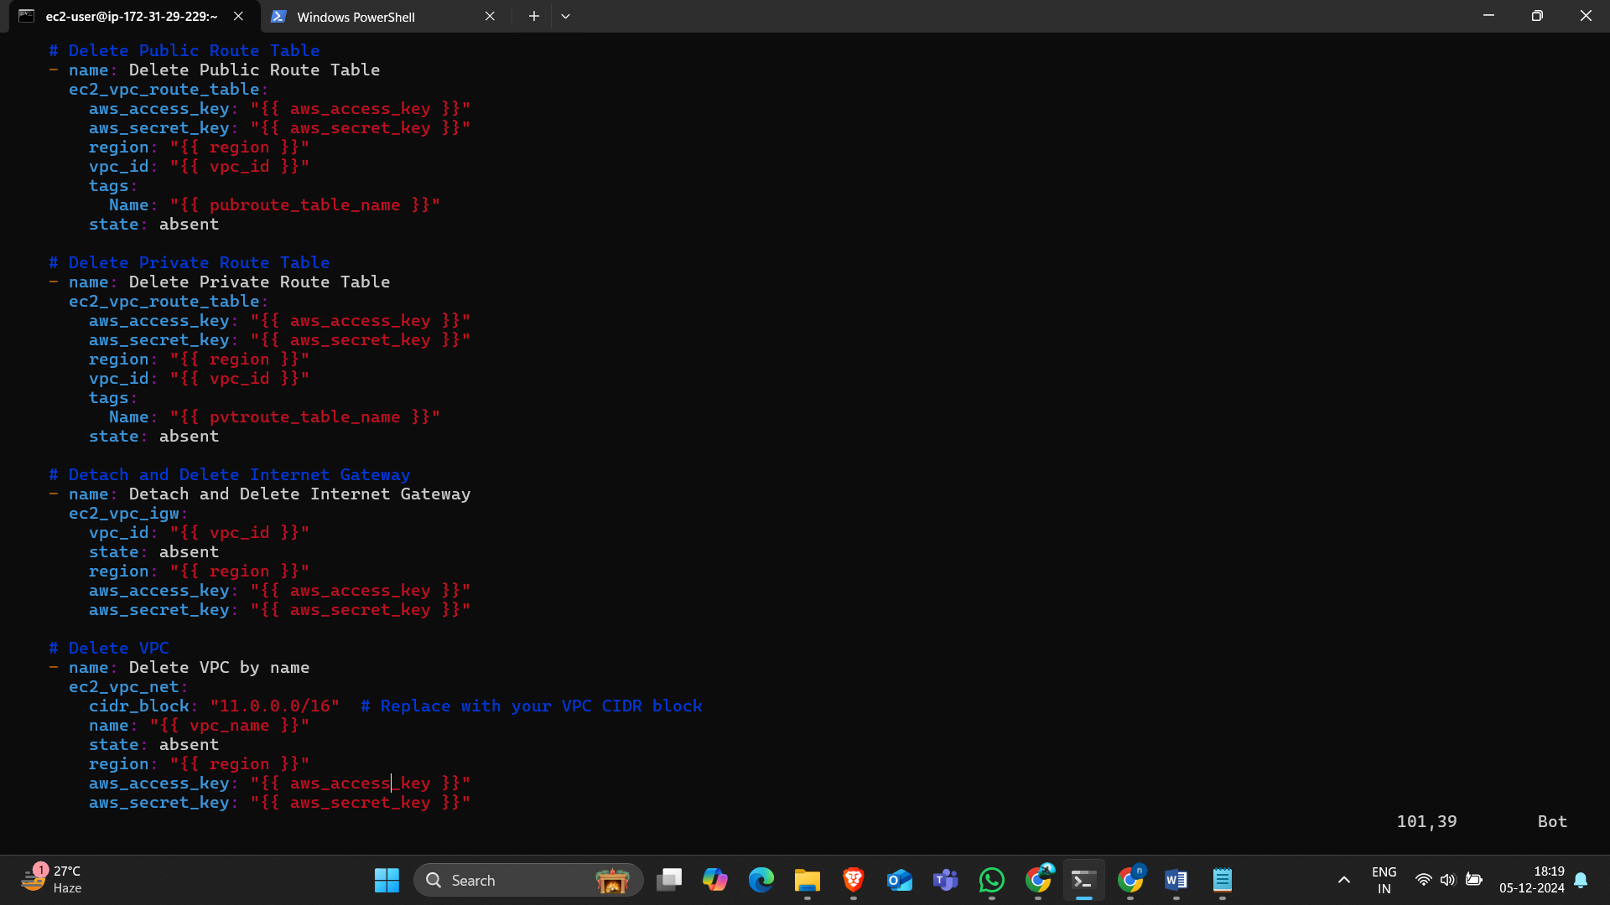

## Method-3 (Outline Variables)

### Create the resources by using the outline variable for playbook.

* Launch an instance by using amazon-linux.

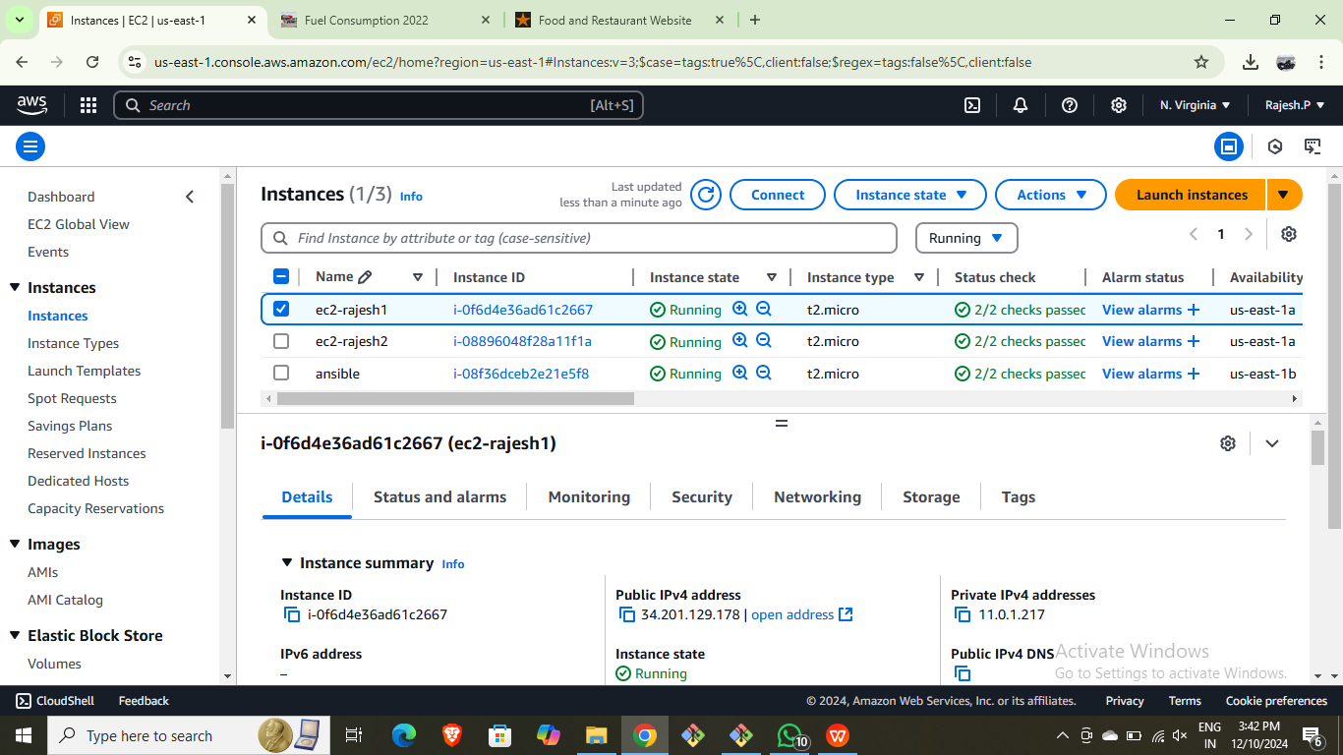

* Connect to the terminal.update it.
* Than copy the pem file and give permission.
* Change the hosts file and configure file of ansible.
* Go to usr/bin/ than install the boto boto3 botocore.
* Write the userdata files,
* Write the outline variable file and name it “secret.yaml”
* Write the playbook file and execute.

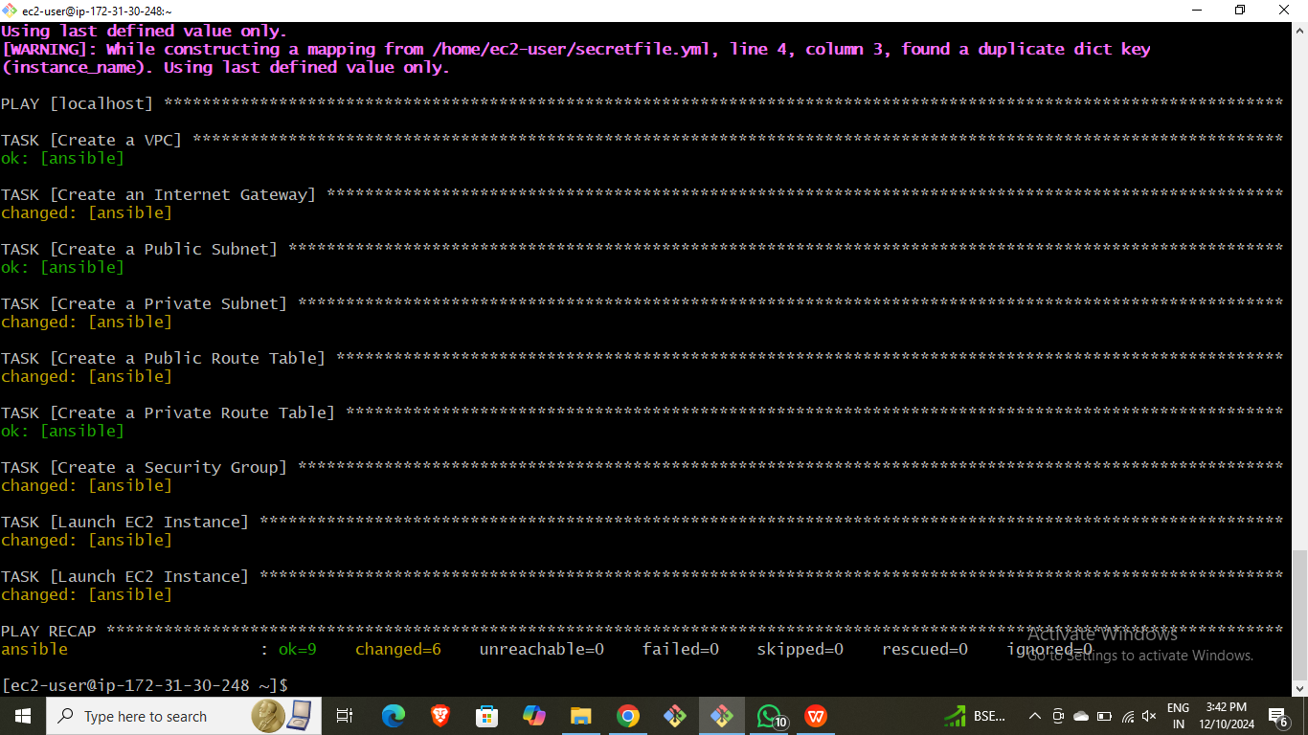

* Here the Outline variable.file “secret.yaml”

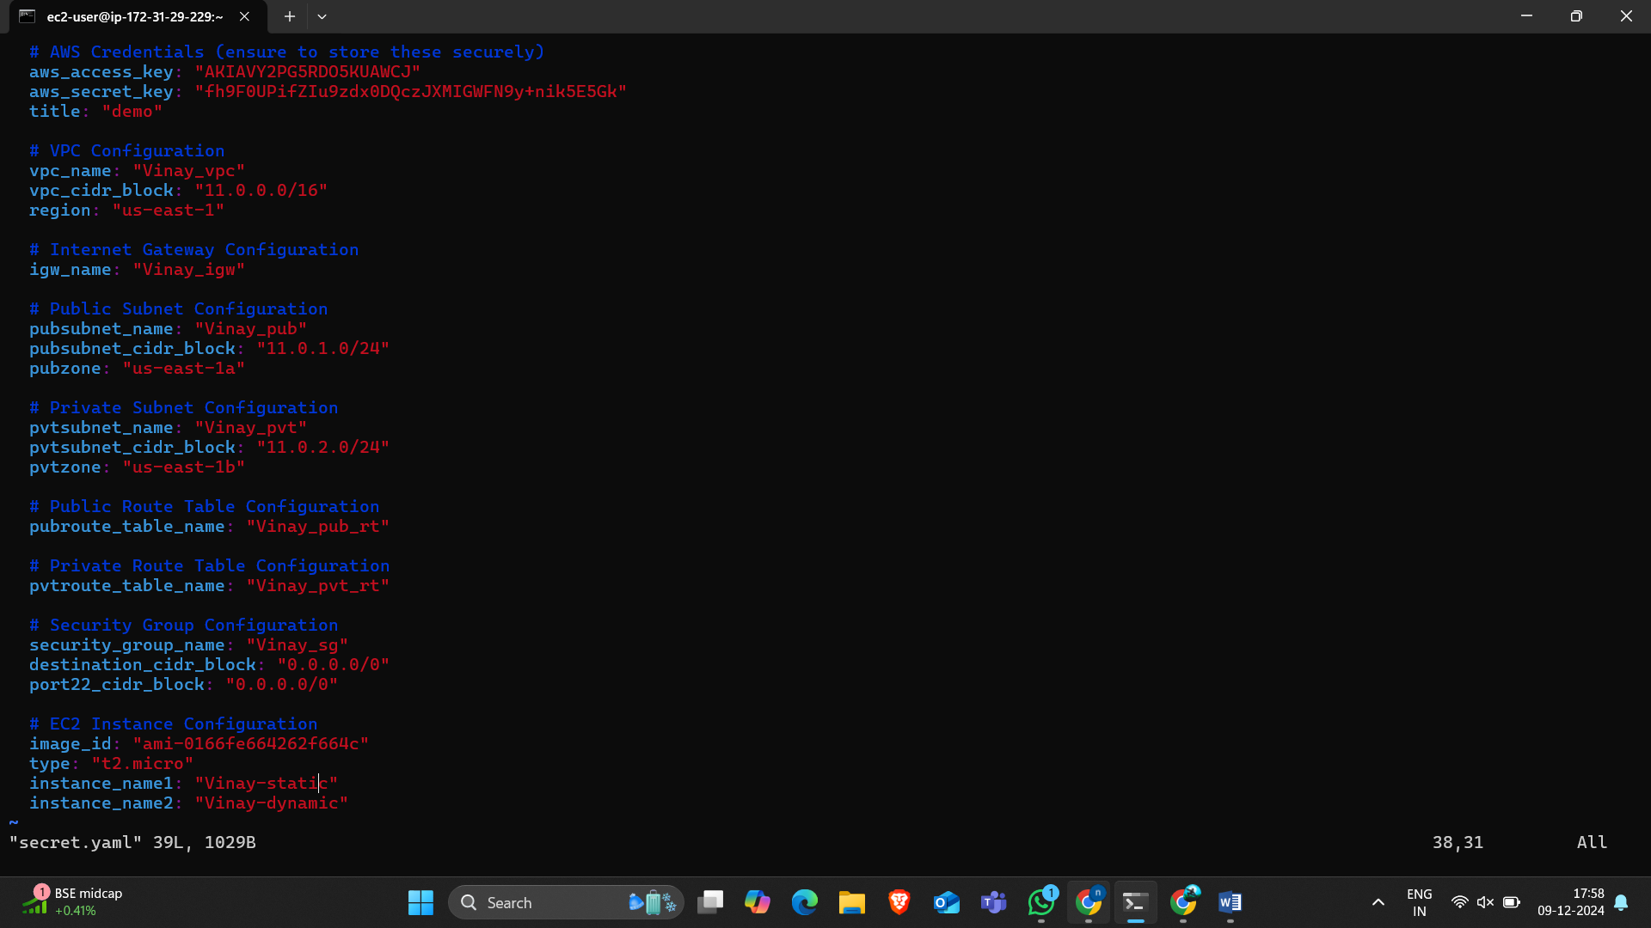

* Here the ansible.yaml.

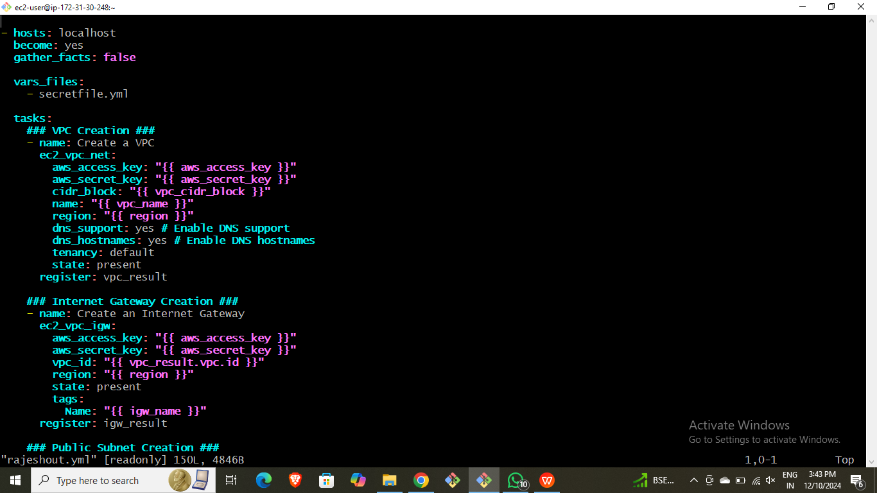

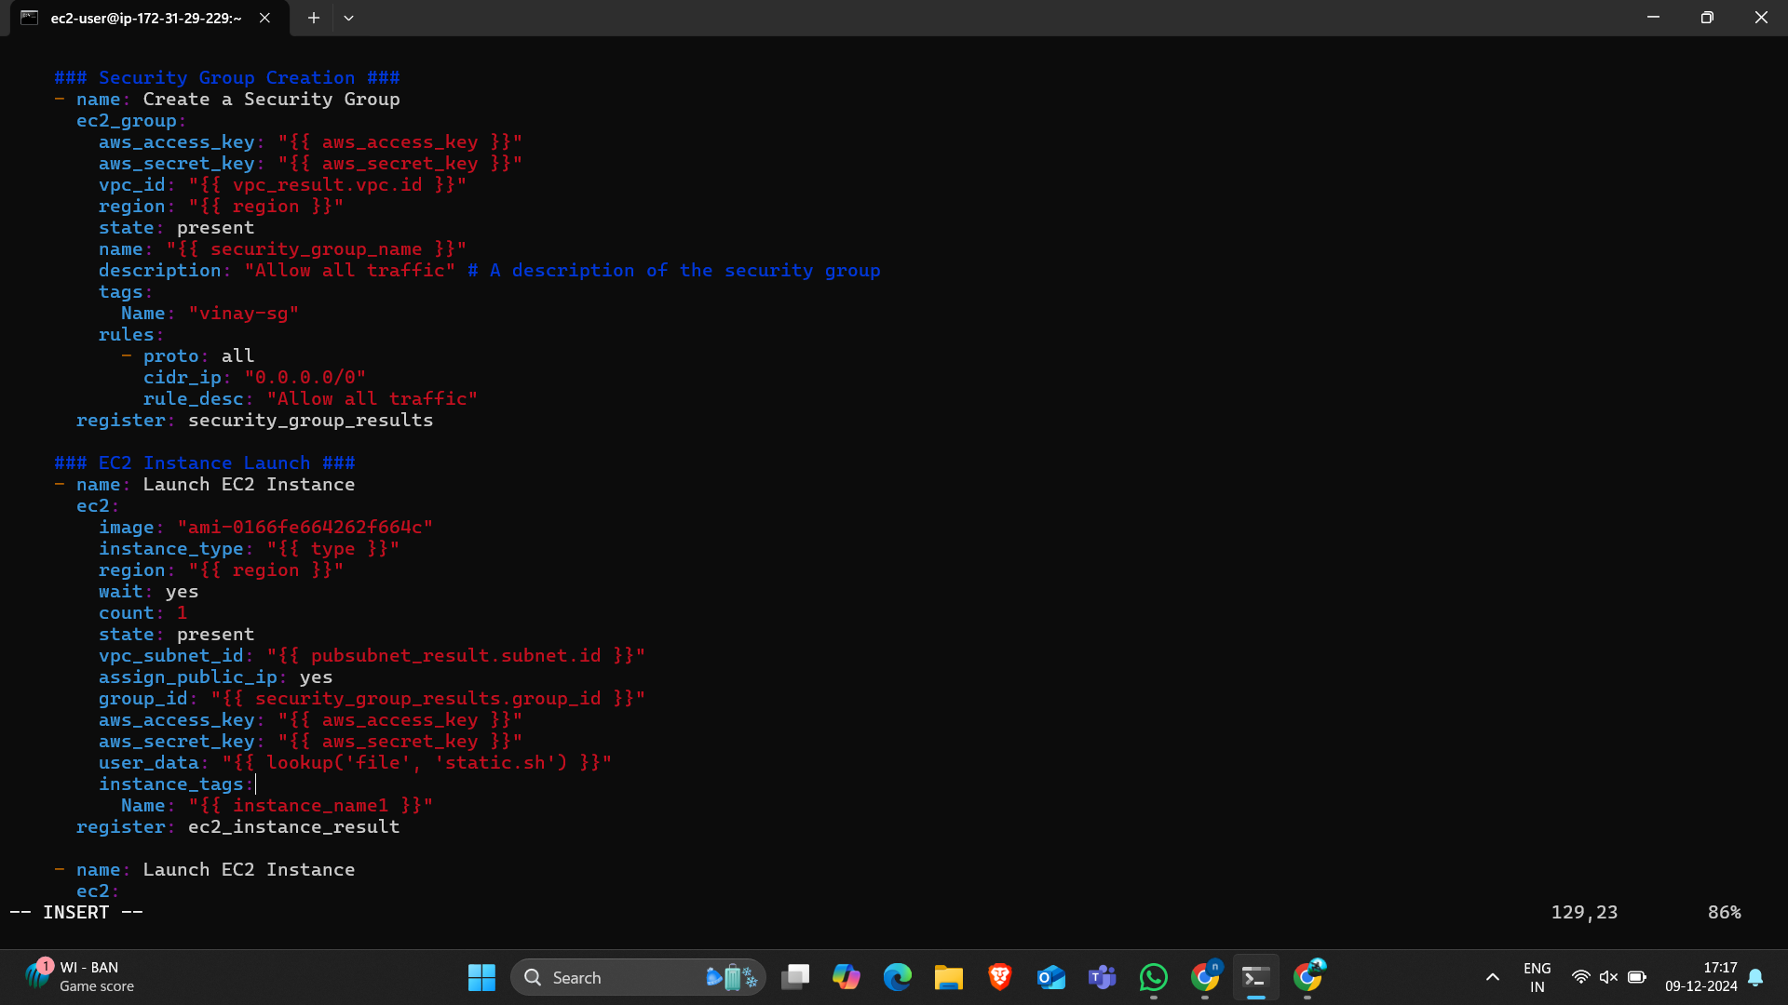

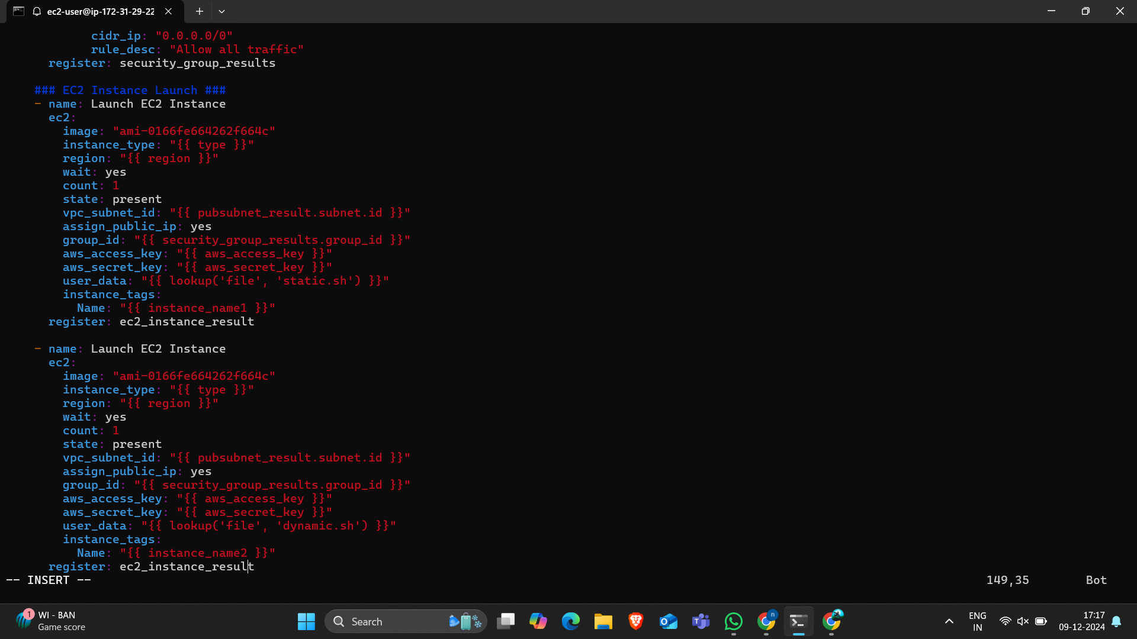

* Execute the playbook file.



* We can observe the created instances.



* Result of static application.

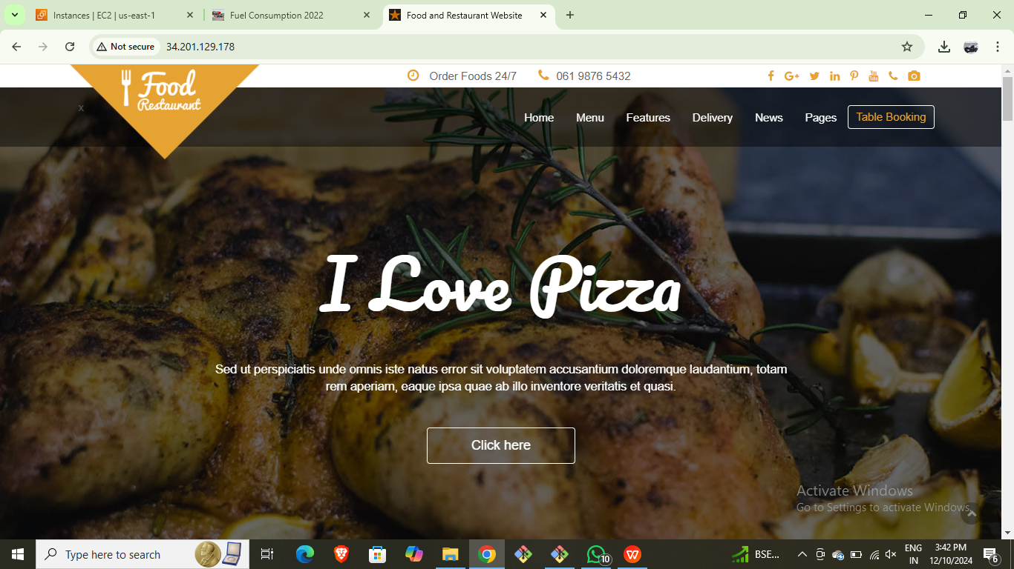

* Instance-2



* Result of dynamic application.

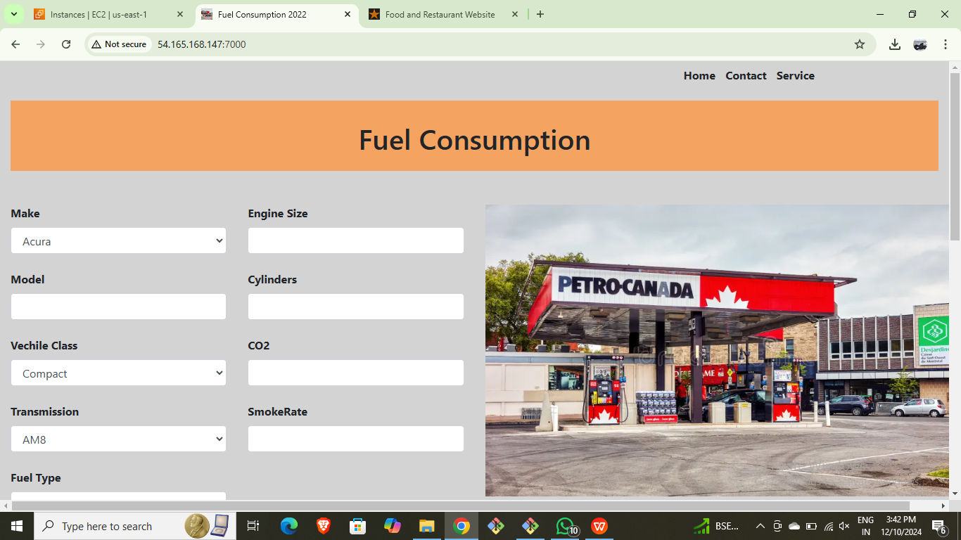

* Here playbook script for deletion.

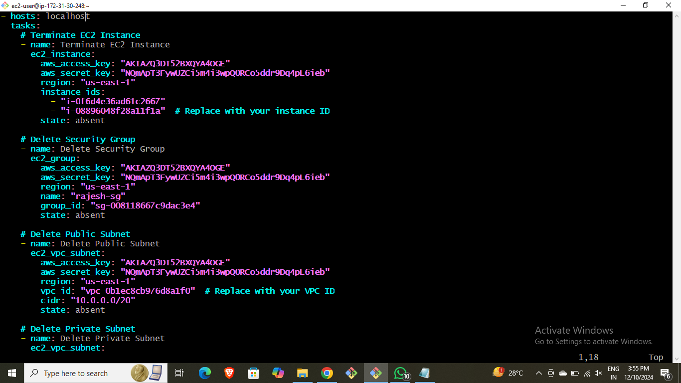

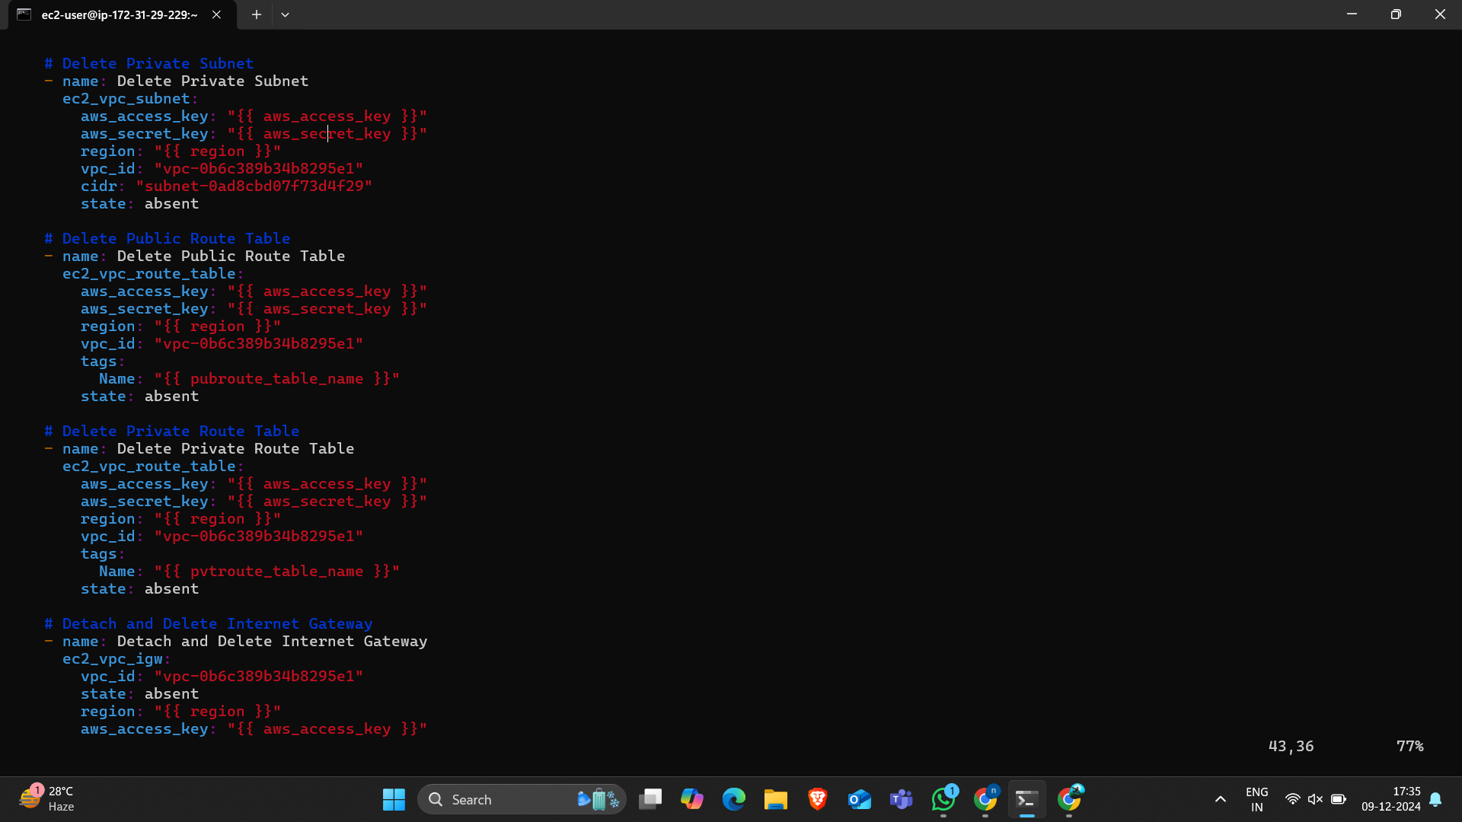

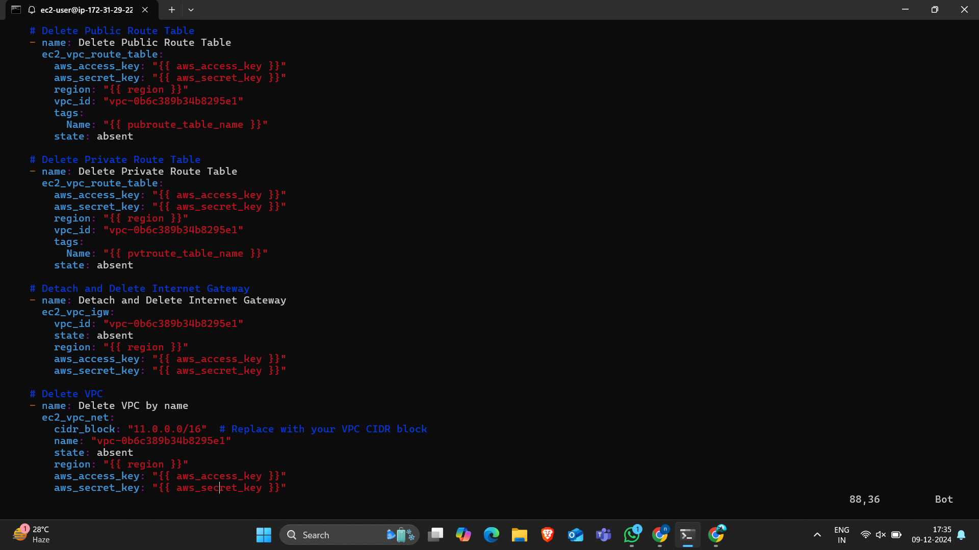

* Execute the deletion script file.

